THE UNIVERSITY OF FAISALABAD

DEPARTMENT OF COMPUTER SCIENCES

PROGRAMMING FOR AI
AI-212

LAB MANUAL

SUBMITTED BY : AYESHA IMRAN
REGISTRATION NO : 2023-BSAI-011
SUBMITTED TO : SIR SAMRAIZ
DEGREE : ARTIFICIAL INTELLIGENCE

TABLE OF CONTENTS
Lab 01 –
Programming fundamentals of python………………………………………….3
Lab 02 –
Pf in python………………………………………………..……………..…….…10
Lab 03 –
Loops and conditions……………………………………………………………...14
Lab 04 –
Loops and conditions p2……………………………………………………..……18
Lab 05 –
Object oriented programming in python …………………………………….…22
Lab 06 –
Op in python…………………………………………………………………..…32
Lab 07 –
Op in python p2………………………………..…………………………….……37
Lab 08 –
Op in python p3 …………………………………………………….……………...42
Lab 09 –
Numpy in python………………………………………………………….…….…47
Lab 10 –
Numpy as np in python ……………………………………………………………55
Lab 11 –
Seaborn …………………………………………………………………….……...61
Lab 12 –
Scikit - learn………………………………………………………………….….…68
Lab 13 –
Tensorflow in python ………………………………………………………….…75
LAB NO 1

PROGRAMMING FUNDAMENTALS OF PYTHON

What is Programming?
Programming means giving instructions to a computer so it can perform tasks.
Python is a high-level, easy-to-read programming language, widely used in AI, web, data science, and automation.

Python Basics

Print Statement
Used to display output.
print("Hello, World!")

Variables
A variable stores data in memory.
x = 10
name = "Ayesha"
- Python is dynamically typed (no need to declare data type).

Data Types
Type |  | Example
int |  | 10
float |  | 3.5
string |  | "Python"
boolean |  | True / False

age = 20
price = 99.99
is_student = True

Operators

Arithmetic Operators
+ - * / % **

a = 10
b = 3print(a + b) # 13

Comparison Operators
== != > < >= <=

Logical Operators
and or not

Input from User
name = input("Enter your name: ")print("Hello", name)
Input is always string, convert if needed:
age = int(input("Enter age: "))

Control Structures

If-Else Statement
Used for decision making.
age = 18if age >= 18:
print("Eligible")else:
print("Not eligible")

Loops

For Loop
for i in range(5):
print(i)

While Loop
i = 1while i <= 5:
print(i)
i += 1

Functions
A function is a block of reusable code.
def add(a, b):
return a + b
print(add(3, 4))

Lists (Collection of Data)
numbers = [1, 2, 3, 4]
print(numbers[0])

Tuples
Immutable (cannot change).
t = (1, 2, 3)

Dictionaries
Key-value pairs.
student = {"name": "Ayesha", "age": 20}
print(student["name"])

Strings
text = "Python"print(text.upper())

Comments
# This is a comment
Q1. Banking Transaction Validator with PIN
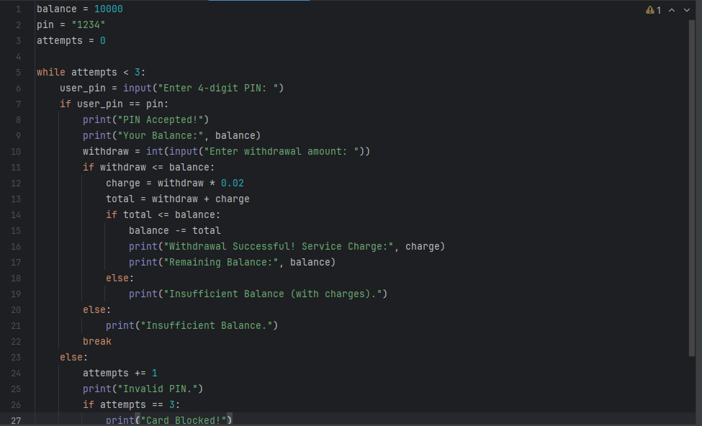
Output:
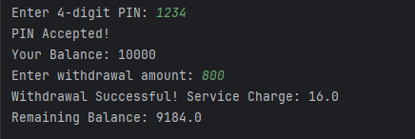
Q2. Grocery Store Inventory System
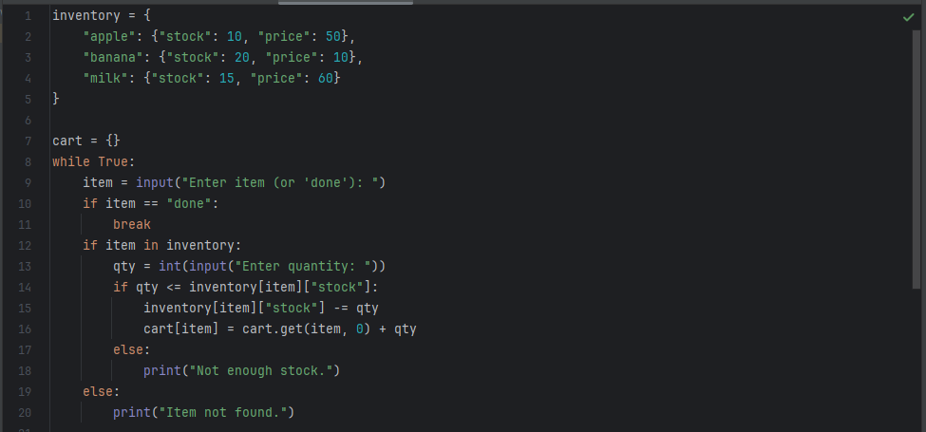
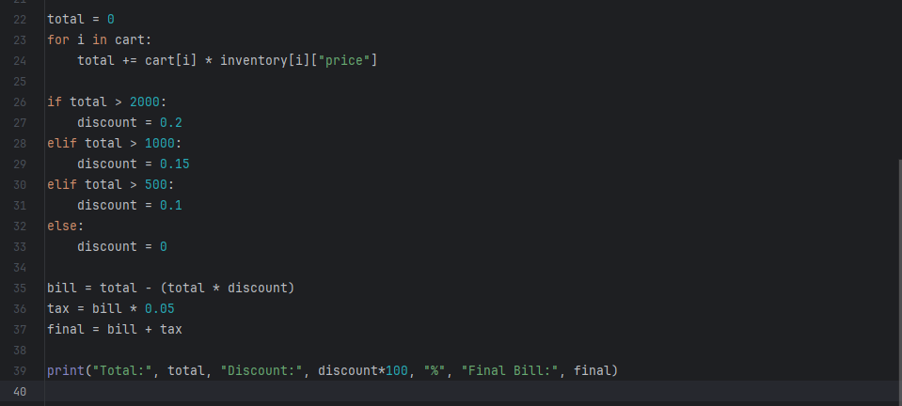
Output:
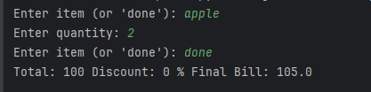

Q3. Student Grading with Subject Weightage
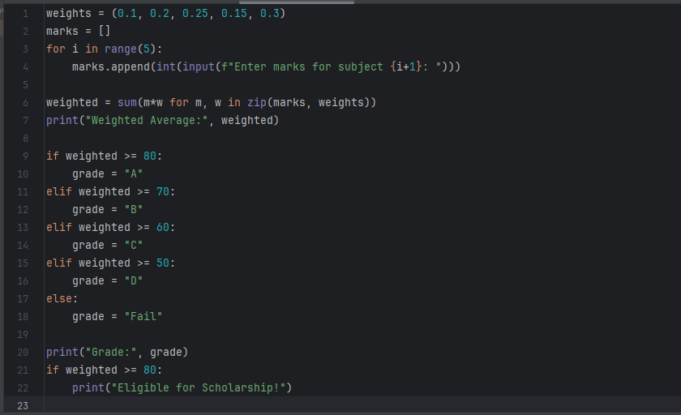
Output:
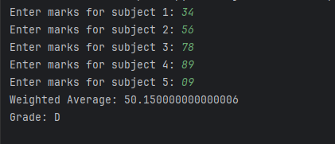

Q4. BMI + Health Recommendation
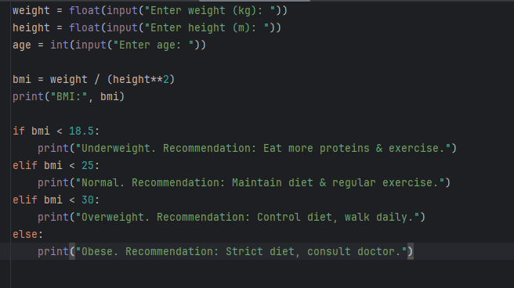
Output:
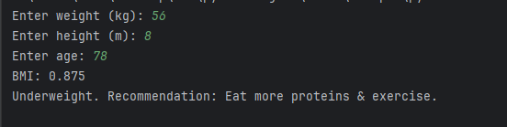
Q5. Telecom Prepaid Recharge system
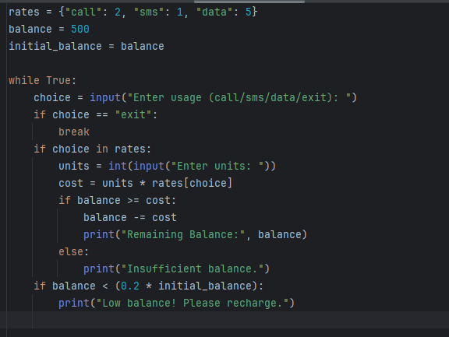

LAB NO 2

PF IN PYTHON

Q1. E-Commerce Discount Engine with Membership Levels
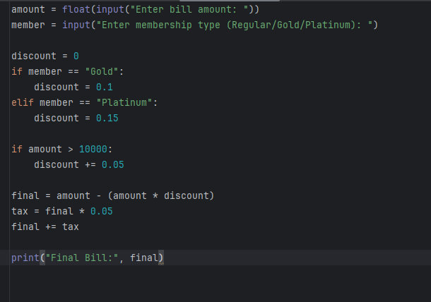
Output:
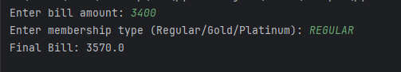
Q2. Hospital Emergency Unit with Multi-Condition Triage
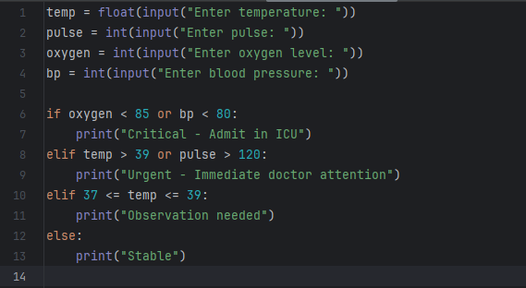
Output:
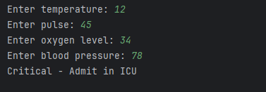
Q3. Online Examination Grader with Negative Marking
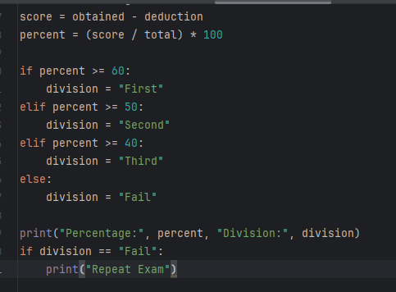
Output:
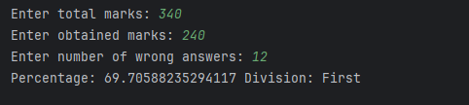

Q4. Movie Ticket Booking with Age & Timing Policy

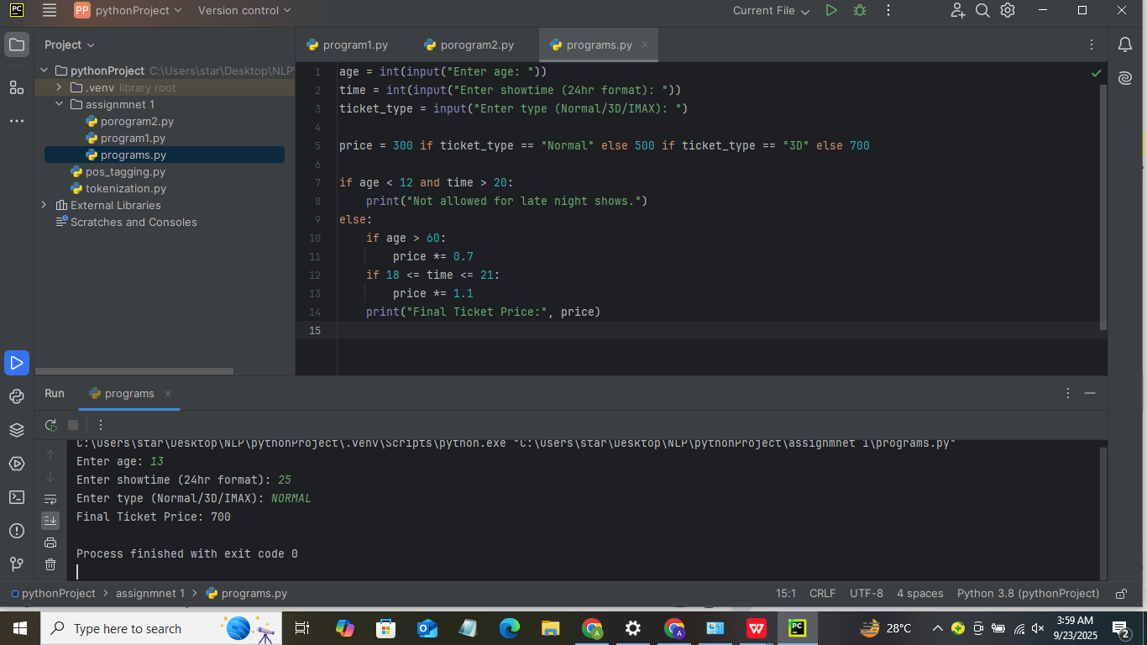
Output :


Q5. Weather-based Outfit + Travel Suggestion
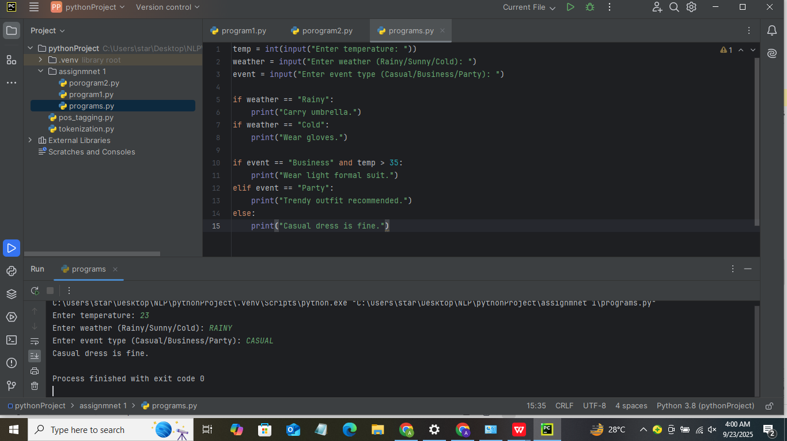
Output :


LAB NO 3

LOOPS AND CONDITIONS

Q1. ATM Withdrawal with Note Counting + Receipt
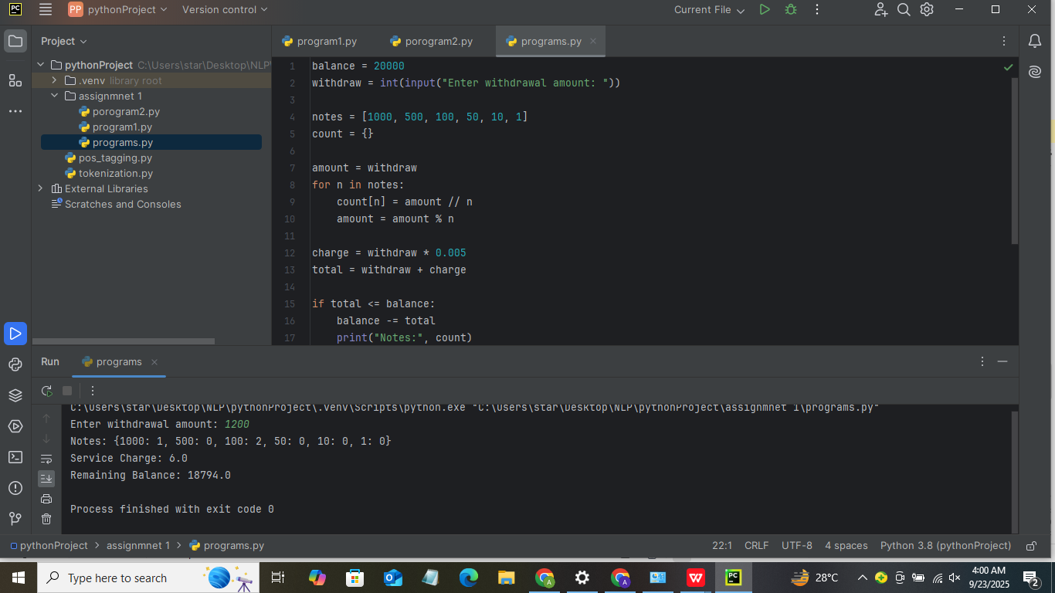
Output :


Q2. Library Fine Calculator with Membership Levels
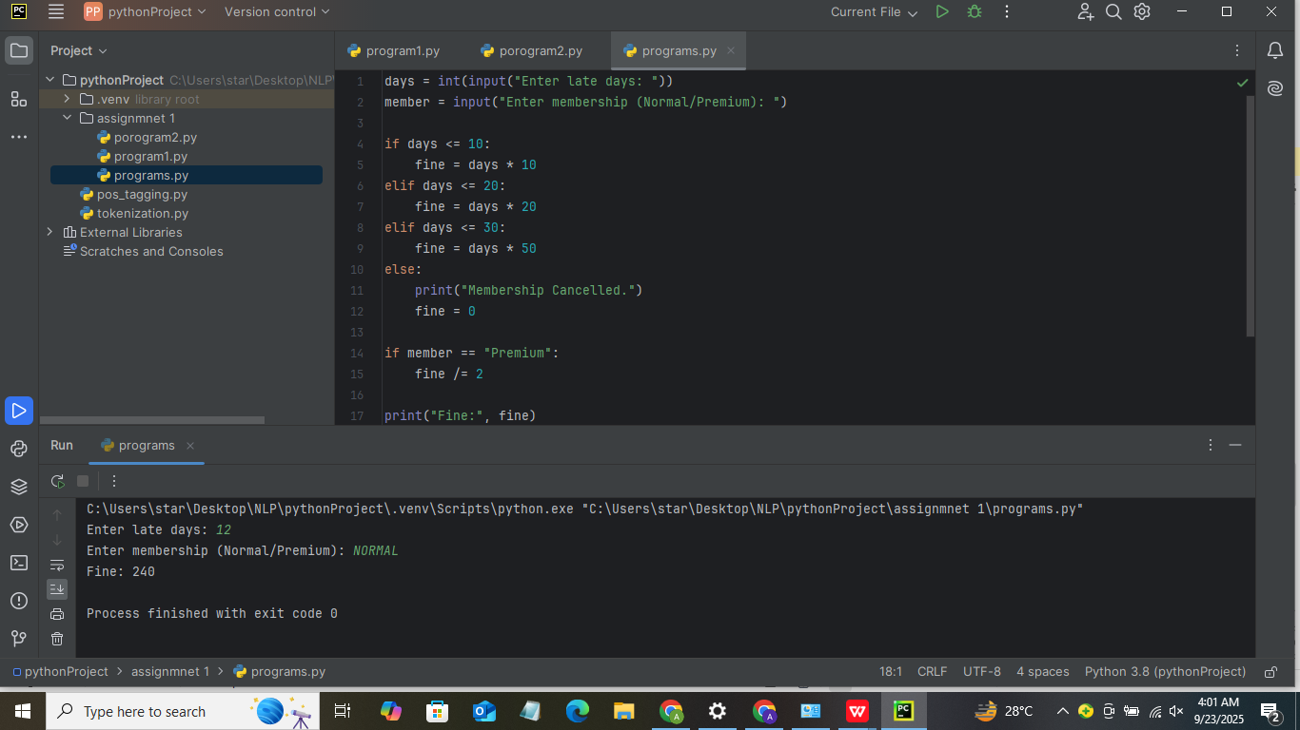
Output :

Q3. Sales Analysis Dashboard
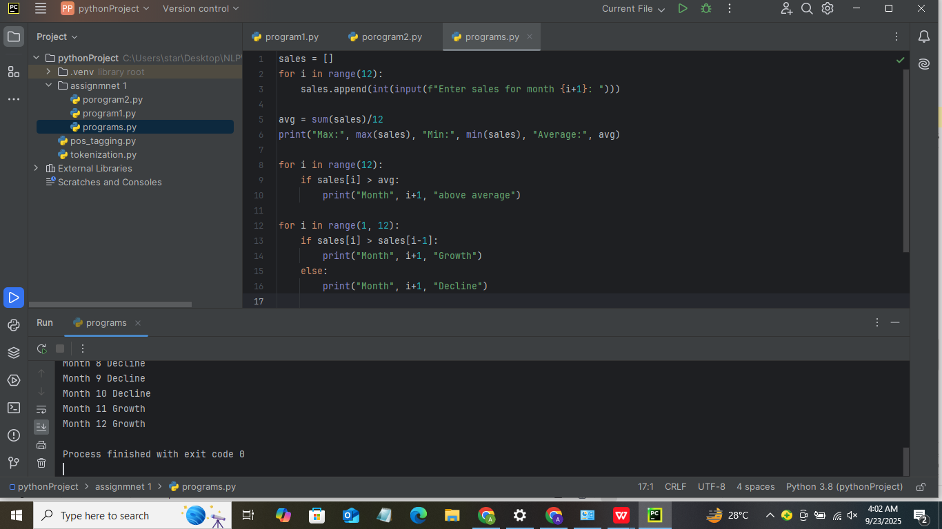
Output:

Q4. Multiplication Puzzle with Random Blanks
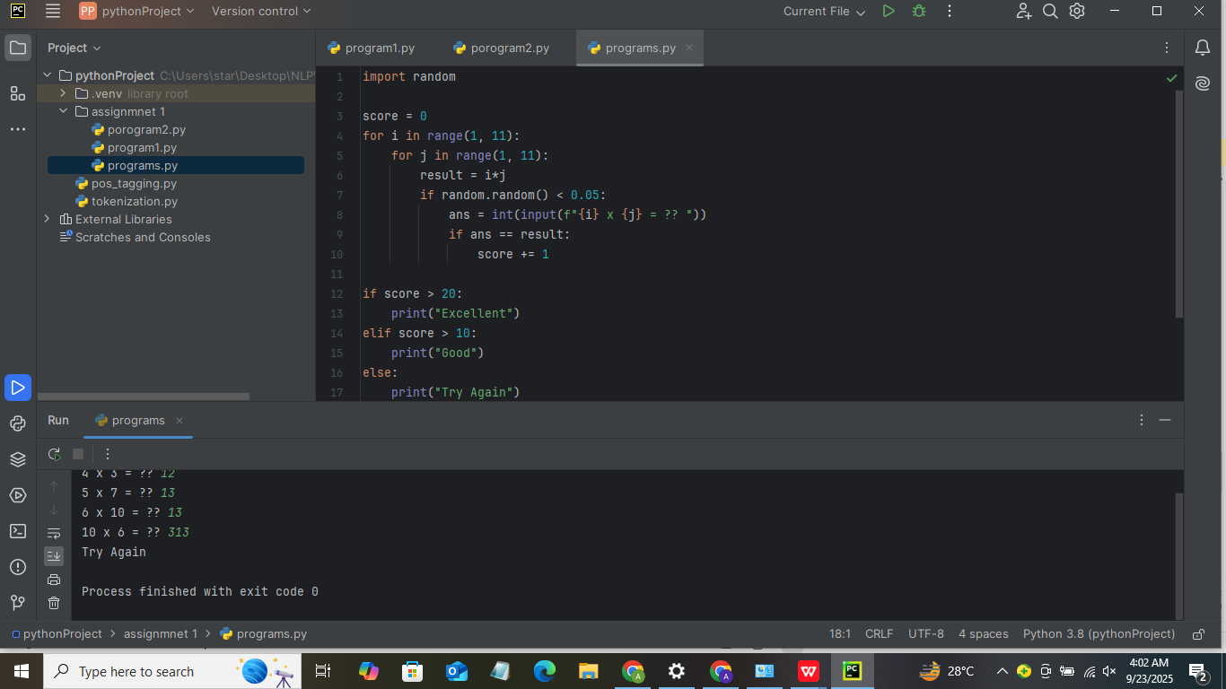
Output :


Q5. Password Strength + Re-entry Attempts
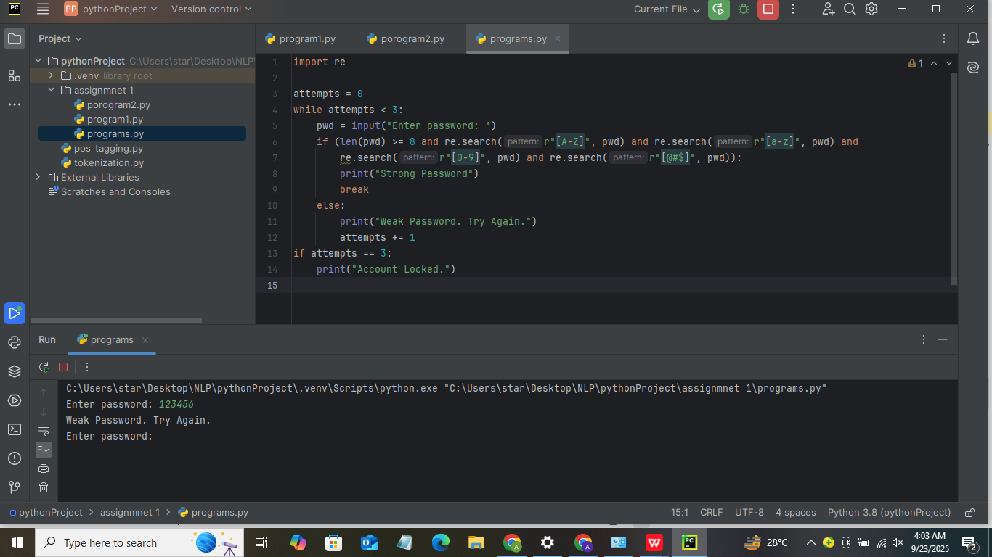
Output :


LAB NO 4

LOOPS AND CONDITIONS P2

Q1. Electricity Bill with Slabs & Penalty
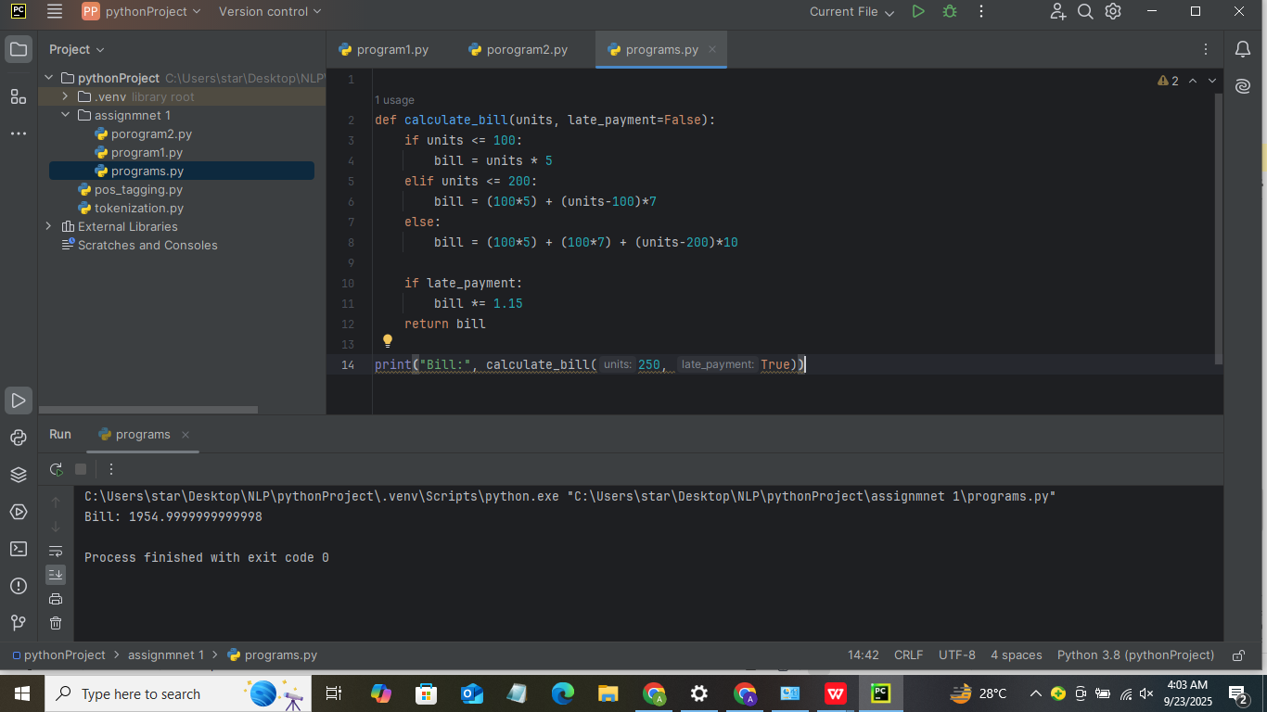
Output:


Q2. Cricket Match Predictor with Multiple Conditions
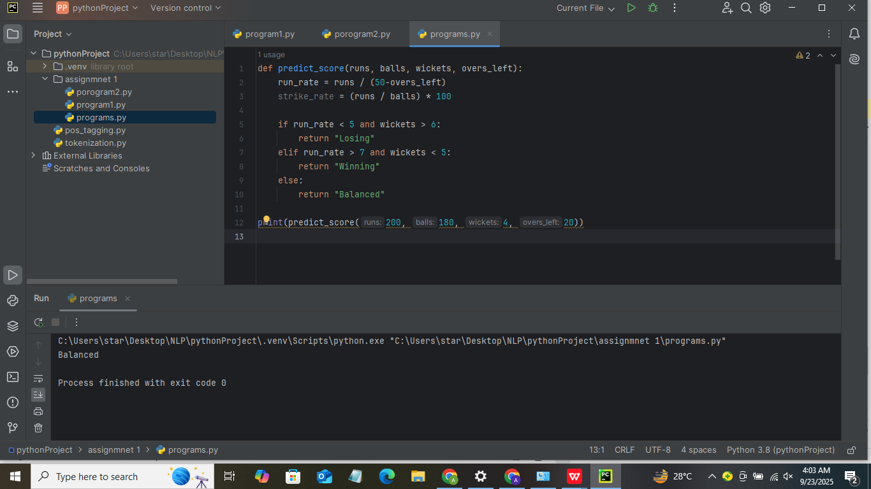
Output:

Q3. Hotel Booking with Tax & Discount
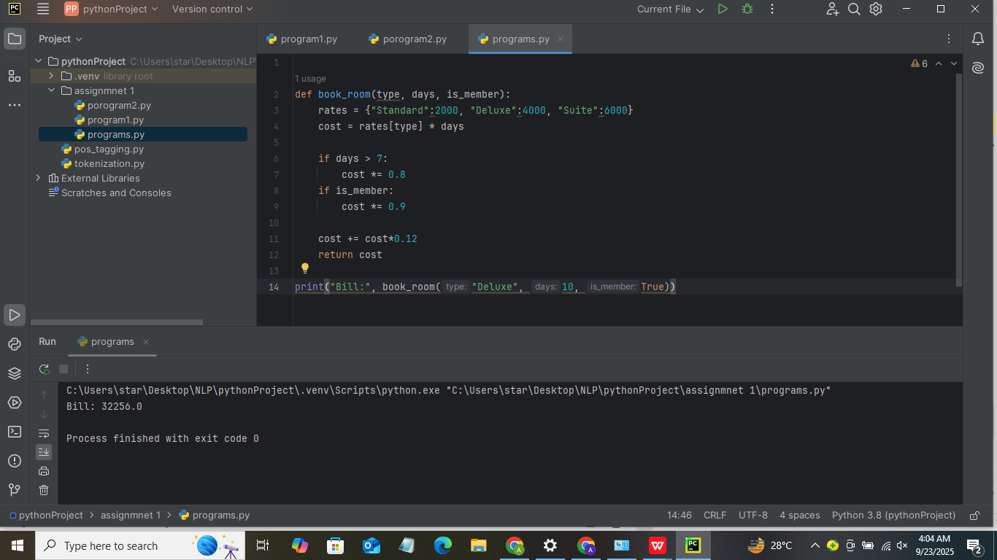
Output:

Q4. Flight Fare Calculator with International Tax
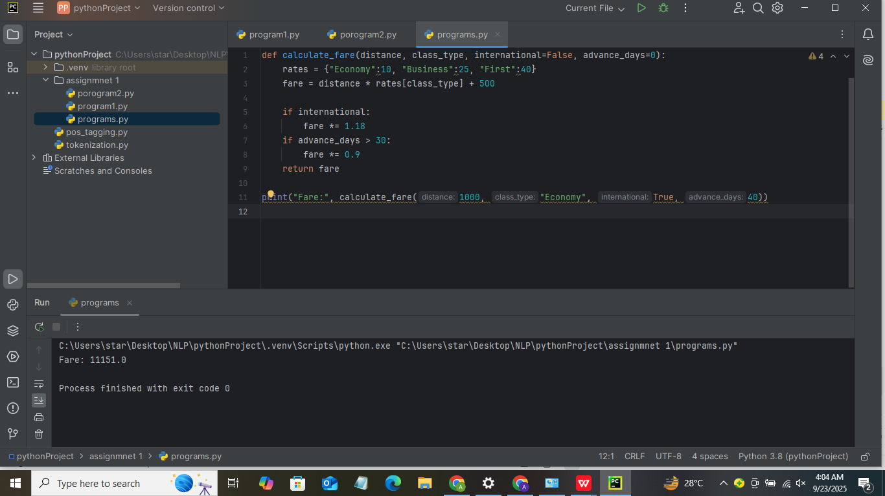
Output:

Q5. Smart Vending Machine with Wallet System
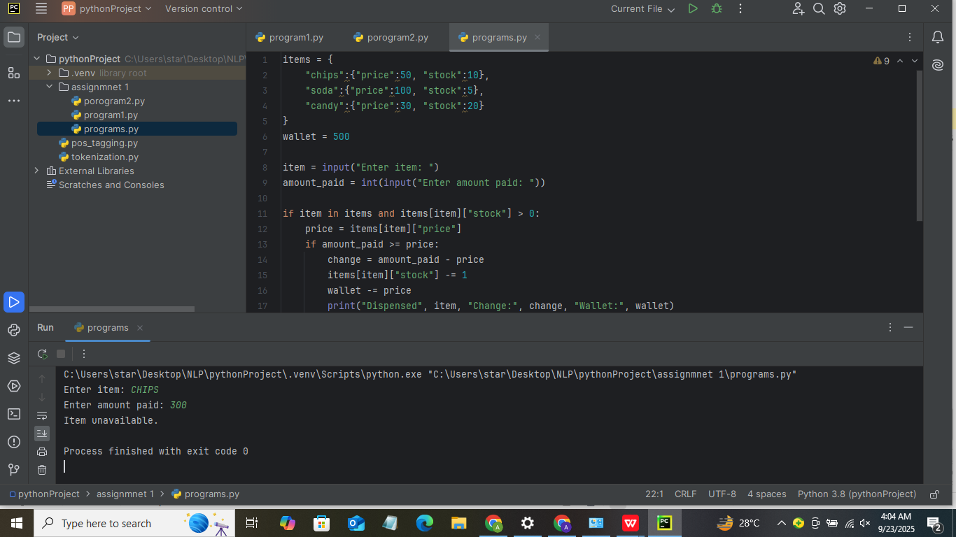
Output:


LAB NO 5

OBJECT ORIENTED PROGRAMMING IN PYTHON

What is OOP?
Object Oriented Programming is a programming approach in which programs are built using objects and classes instead of only functions and logic.
OOP helps in:
Code re-usability
Better organization
Easy maintenance
Real-world modeling

Key Concepts of OOP
There are 4 main pillars of OOP:
- Class
2. Object
3. Encapsulation
4. Inheritance
5. Polymorphism
6. Abstraction

Class
A class is a blueprint or template used to create objects.
class Student:
pass

Object
An object is an instance of a class.
s1 = Student()

Constructor (__init__)
A constructor initializes object data automatically.
class Student:
def __init__(self, name, age):
self.name = name
self.age = age

Instance Variables & Methods
Variables and functions inside a class.
class Student:
def __init__(self, name):
self.name = name

def display(self):
print("Name:", self.name)

Encapsulation
Encapsulation means binding data and methods together and hiding data.
class Account:
def __init__(self):
self.__balance = 0 # private variable

def deposit(self, amount):
self.__balance += amount
__balance cannot be accessed directly.

Inheritance
Inheritance allows a class to reuse another class's properties.
class Person:
def show(self):
print("I am a person")
class Student(Person):
pass

s = Student()
s.show()
✔ Student inherits Person

Types of Inheritance in Python
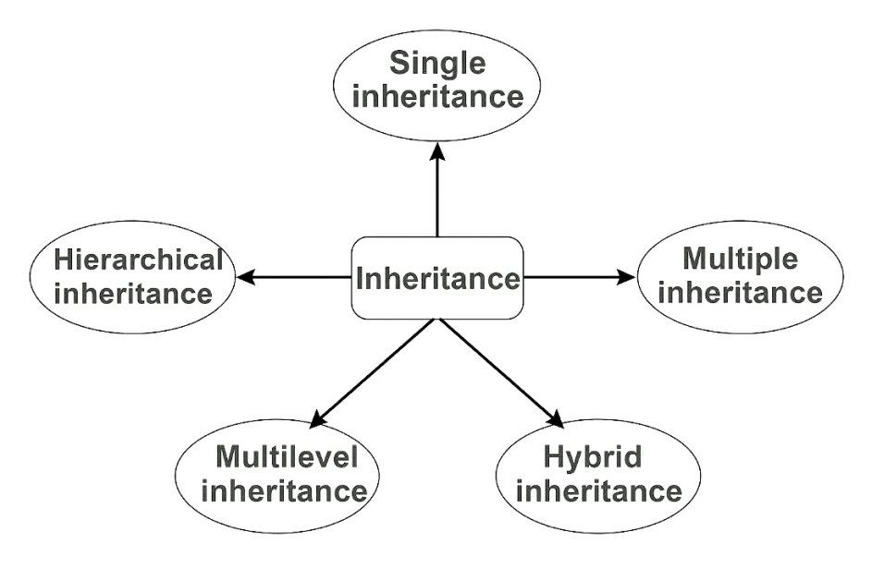

Example (Multiple Inheritance):
class A:
pass
class B:
pass
class C(A, B):
pass

Polymorphism
Polymorphism means same function name, different behavior.

Method Overriding
class Parent:
def show(self):
print("Parent")
class Child(Parent):
def show(self):
print("Child")

Operator Overloading
print(5 + 3)
print("Hello" + "World")

Abstraction
Abstraction means hiding implementation details and showing only necessary features.
from abc import ABC, abstractmethod
class Shape(ABC): @abstractmethod
def area(self):
pass

Access Modifiers in Python

Modifier | Syntax | Meaning
Public | name | Accessible everywhere
Protected | _name | Accessible in subclass
Private | __name | Accessible only inside class

self Keyword
self represents the current object.
self.name

super() Function
Used to access parent class constructor.
class Child(Parent):
def __init__(self):
super().__init__()

Question # 1: Create a `BankAccount` class that represents a bank account. It should have attributes for account number, account holder name, and balance. Include methods to deposit, withdraw, and display balance. Ensure withdrawals cannot exceed the available balance.
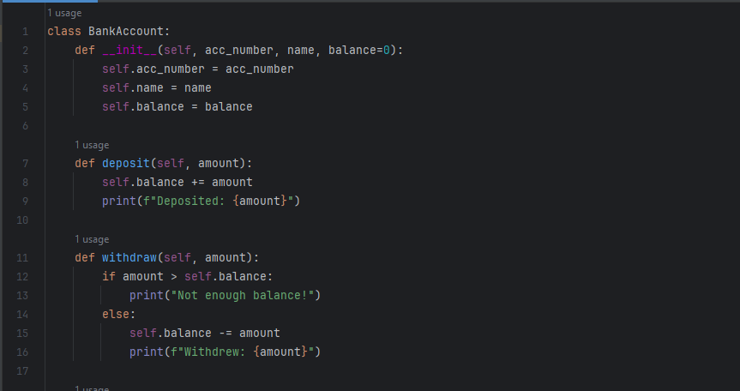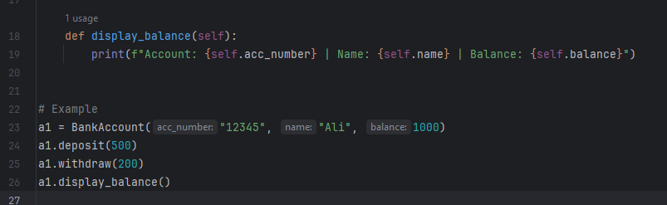
Output :
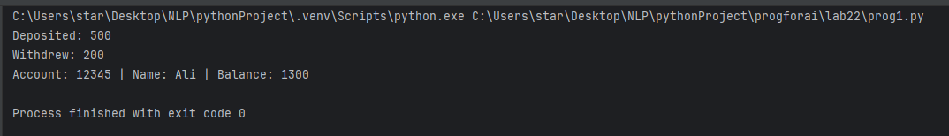

Question # 2: Design a `Book` class with attributes like title, author, ISBN, and availability status. Create a `Library` class that can add books, search for books by title/author, check out books, and return books. Track which books are currently available.
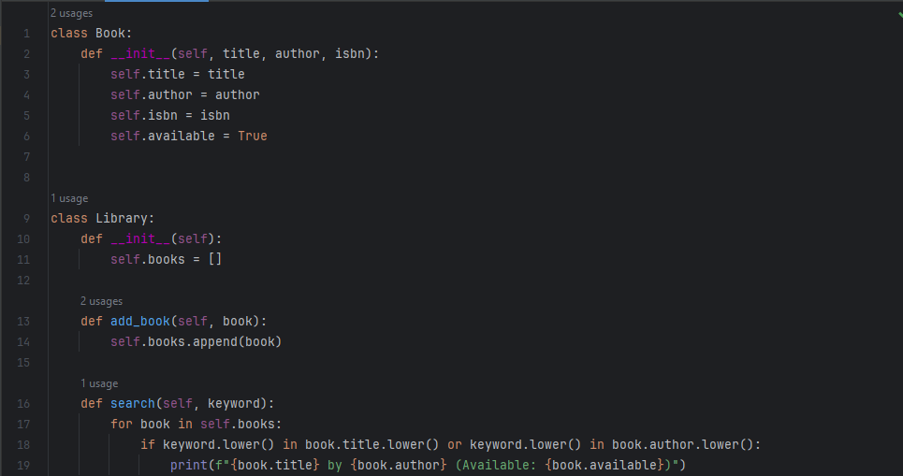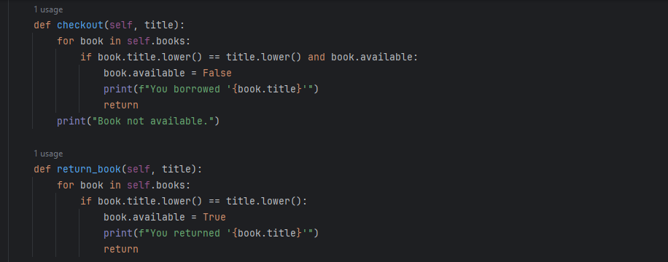
Output :
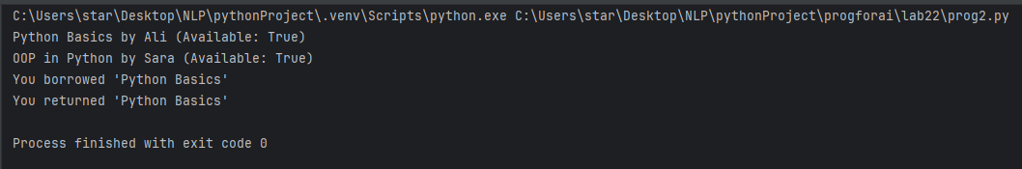

Question # 3: Create a `Student` class with attributes for student ID, name, and a list of grades. Implement methods to add grades, calculate average grade, and determine the letter grade (A, B, C, etc.). Add a method to display student information with their performance summary.
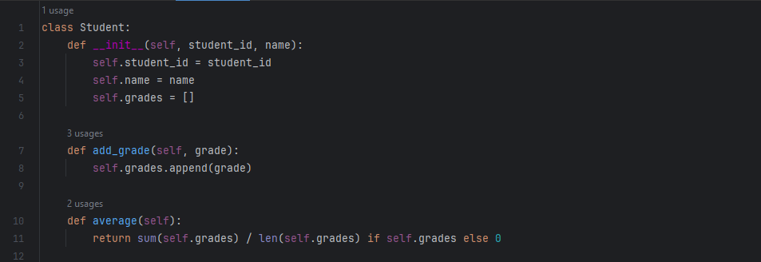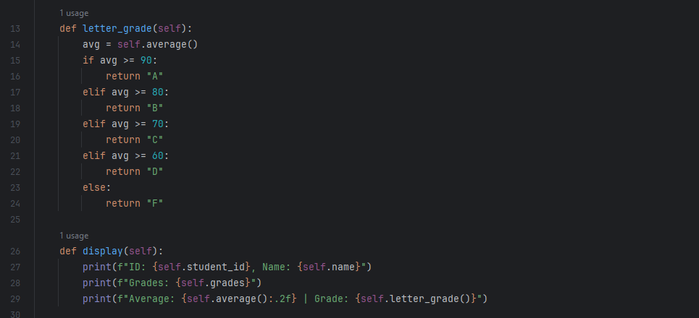
Output :
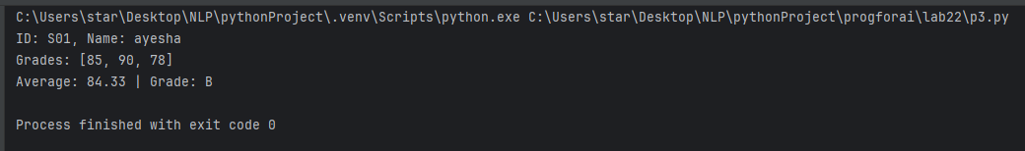

Question # 4: Design a `MenuItem` class for food items (name, price, category) and an `Order` class that can add multiple items, calculate total cost, apply discounts, and generate receipts. Include tax calculation functionality.
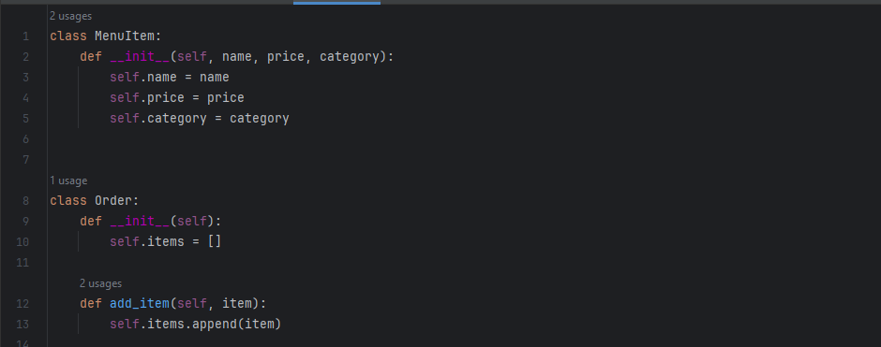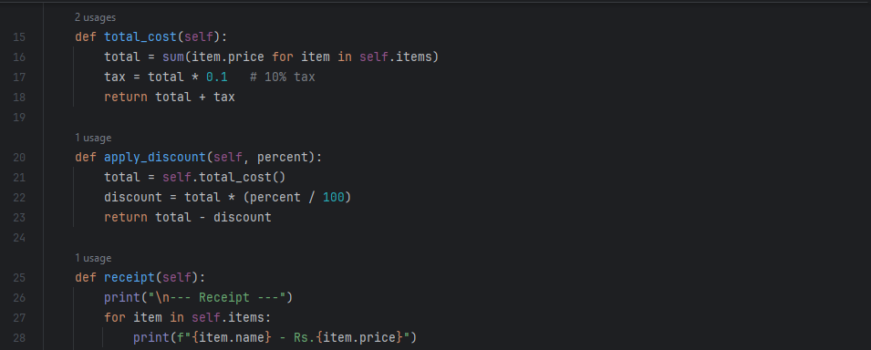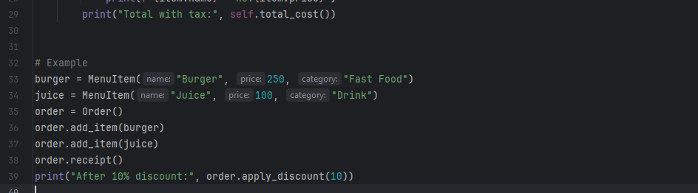
Output :
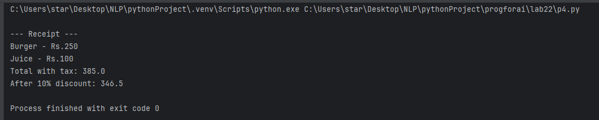

Question # 5: Create classes for `Vehicle` (base class) and derived classes `Car`, `Motorcycle`, and `Truck`. Each vehicle should have attributes like license plate, model, rental price per day, and availability. Implement a system to rent vehicles and calculate rental costs.
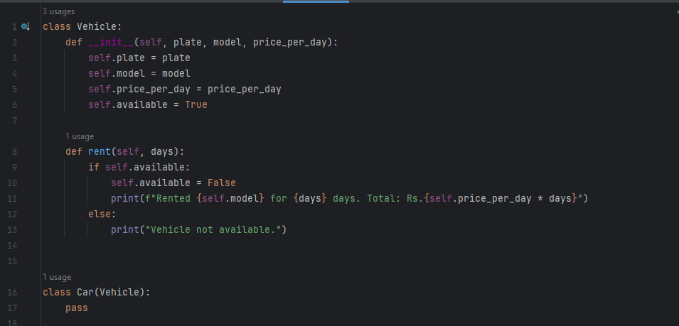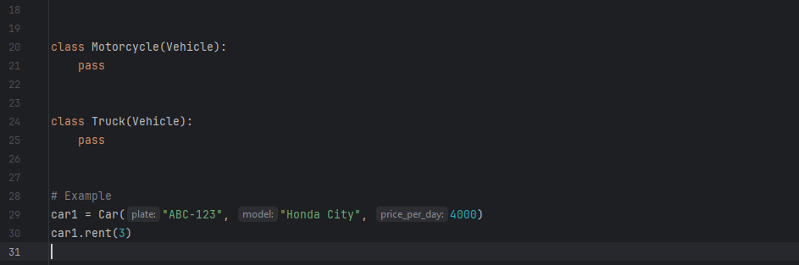
Output :
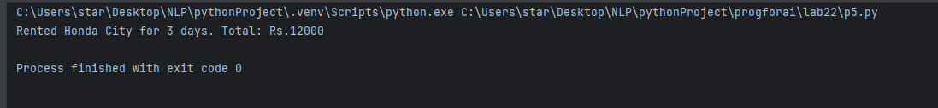

LAB NO 6

OP IN PYTHON

Question # 1: Design an `Employee` class with attributes for employee ID, name, position, and salary. Create methods to calculate monthly salary, annual salary, and apply raises. Include functionality to track employee details and employment duration.

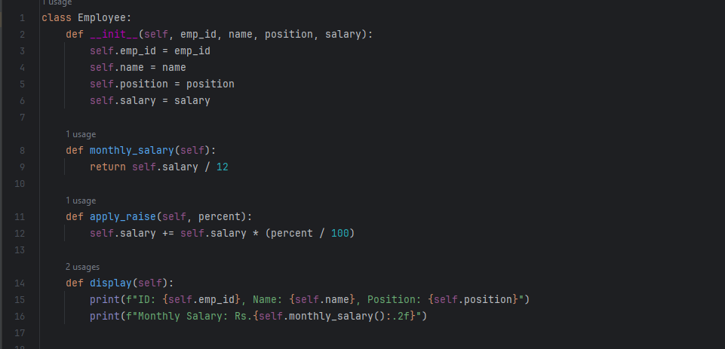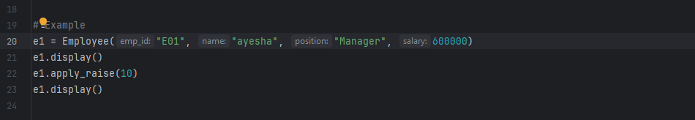
Output :
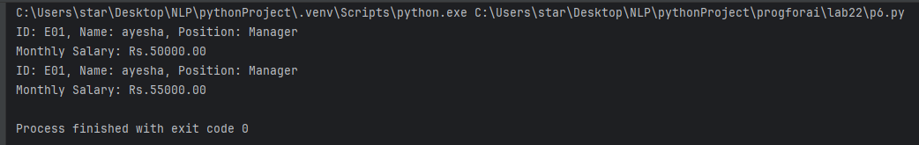

Question # 2: Create a `Product` class with attributes for product ID, name, price, and stock quantity. Design a `ShoppingCart` class that can add products, remove products, calculate total cost, and handle checkout process while updating inventory.
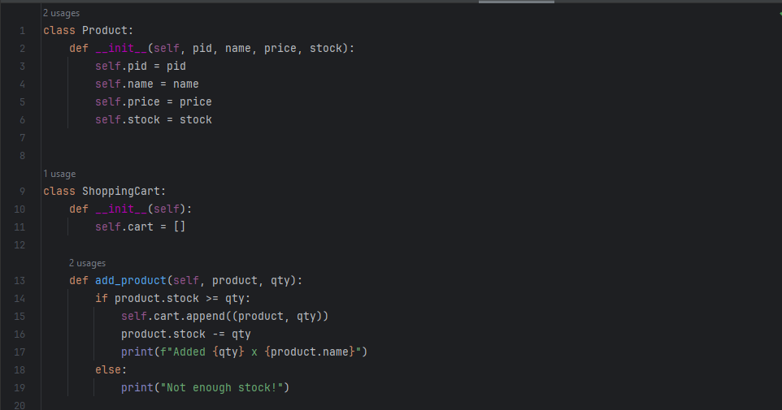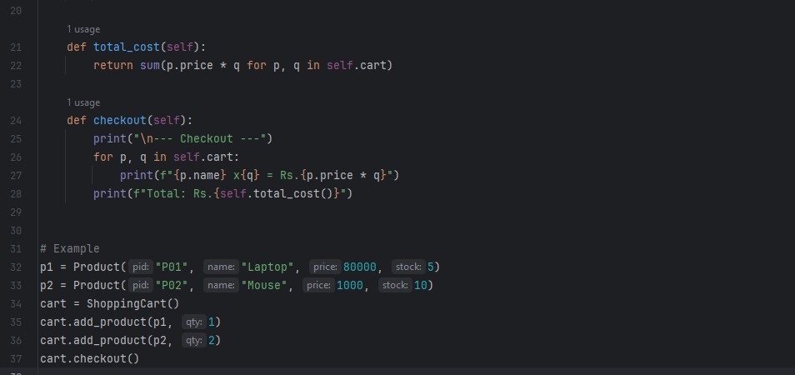
Output:
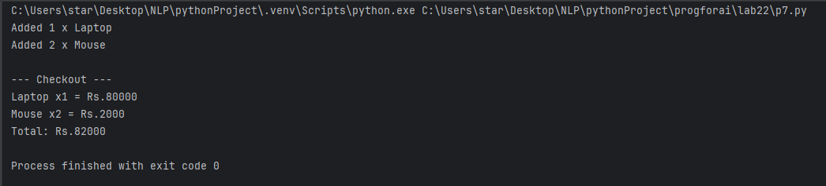

Question # 3: Design a `Patient` class to store patient information (ID, name, age, medical history) and an `Appointment` class to manage doctor appointments. Include functionality to schedule, cancel, and view appointments.
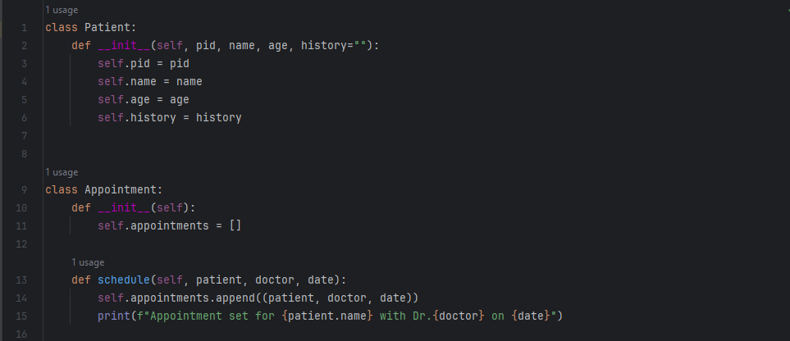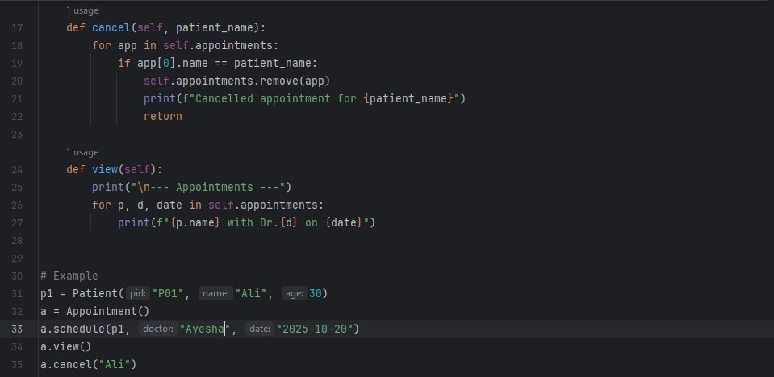
Output
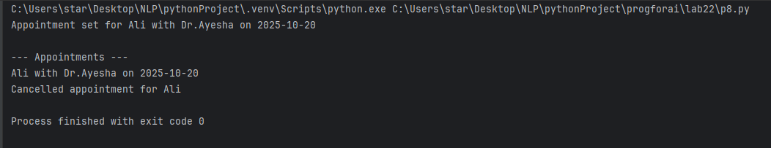

Question # 4: Create a `User` class for a social media platform with attributes for username, email, friends list, and posts. Implement methods to add friends, create posts, and display user timeline. Include privacy settings for posts.
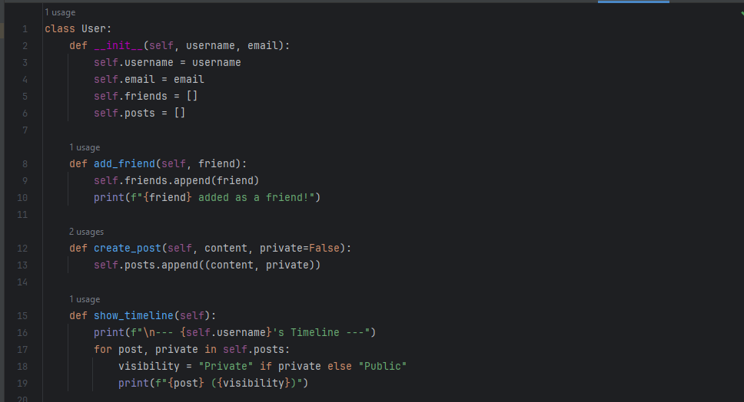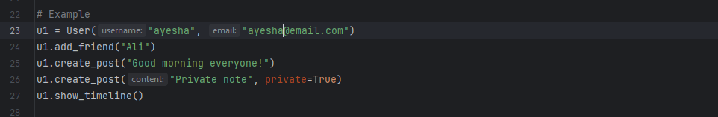
Output
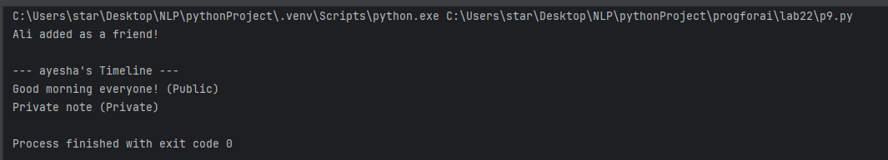

Question # 5: Design a `Room` class with room number, type (single/double/suite), price, and availability. Create a `Booking` class to handle room reservations, check-in/check-out dates, and calculate total stay cost.
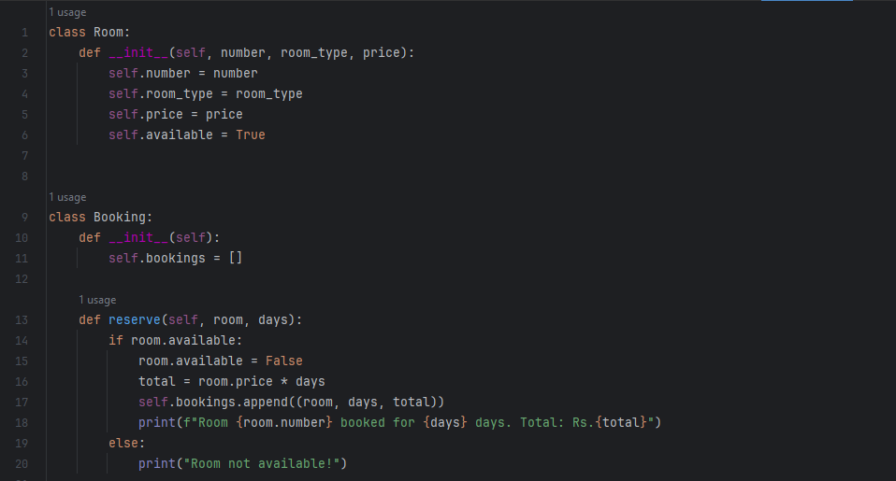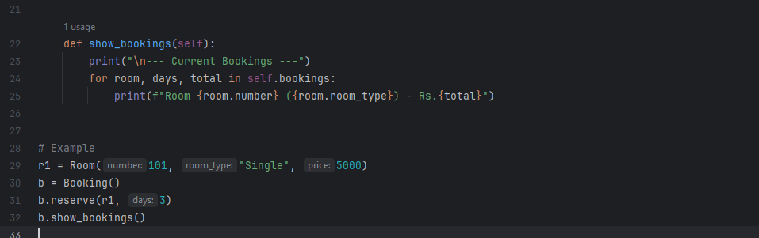
Output :
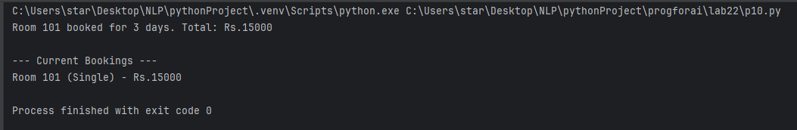

LAB NO 7

OP IN PYTHON P2

Question # 1: Create `Course` classes (with code, name, credits, capacity) and a `Student` class that can register for courses. Implement functionality to check for schedule conflicts and ensure students don't exceed credit limits.
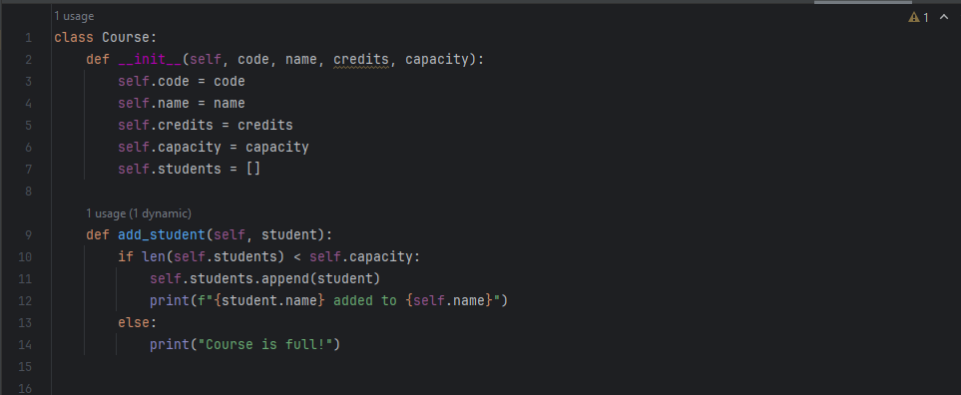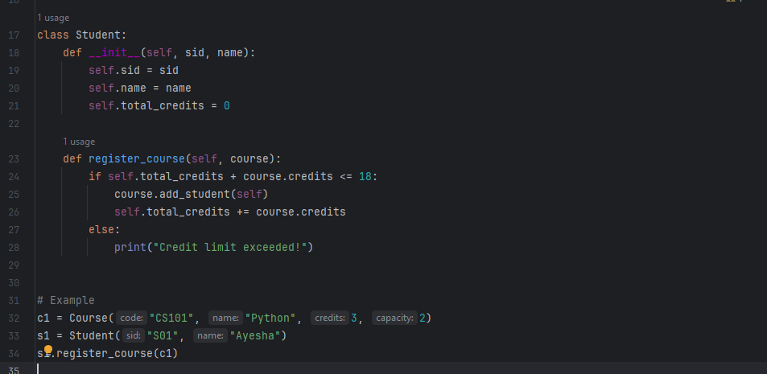
Output
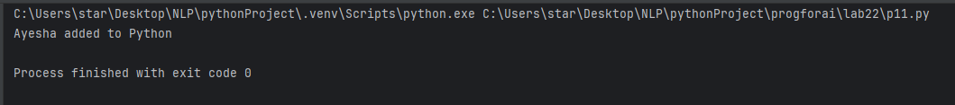

Question # 2: Design a `Product` class for items in inventory (ID, name, quantity, price, supplier) and an `Inventory` class to track stock levels, add new products, update quantities, and generate low-stock alerts.
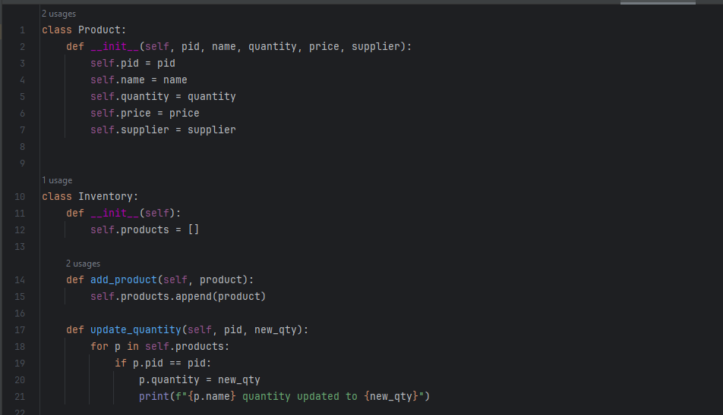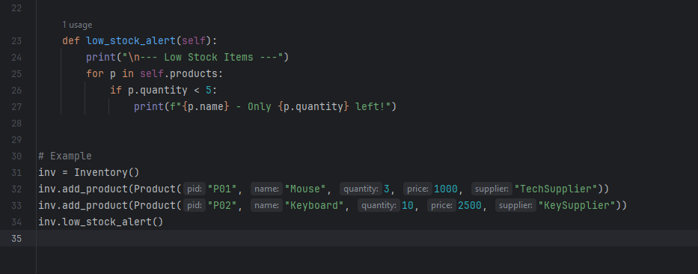
Output
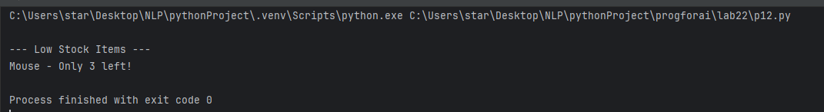

Question # 3: Create `Movie` classes (title, genre, duration, showtimes) and a `Theater` class with seating arrangement. Implement a booking system that reserves seats and calculates ticket prices with different categories (standard, premium).
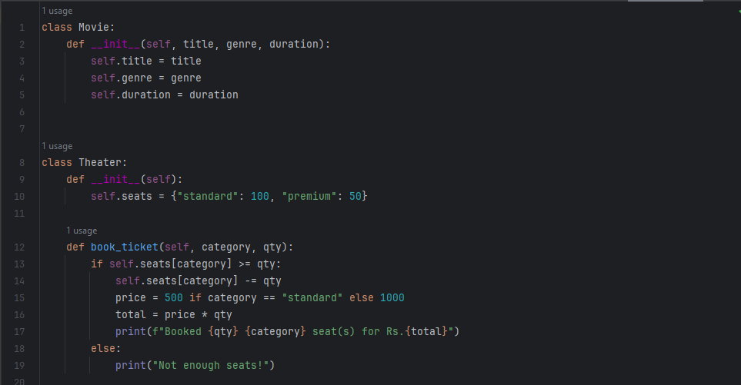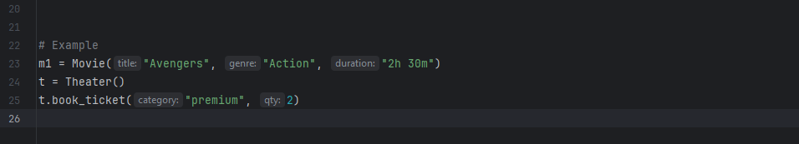
Output
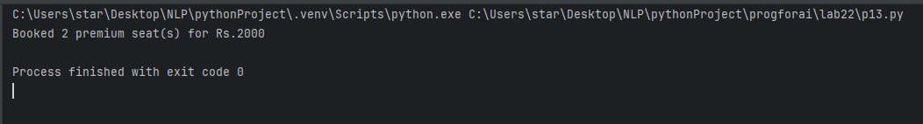

Question # 4: Design a `Member` class with personal details, membership type (basic/premium), and attendance records. Create a `Trainer` class and a system to schedule training sessions between members and trainers.
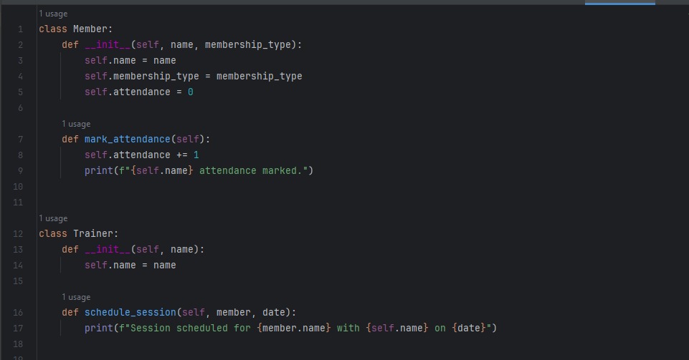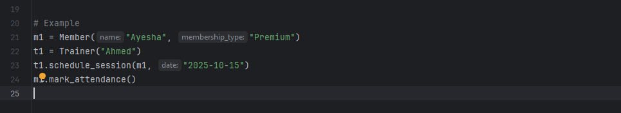
Output
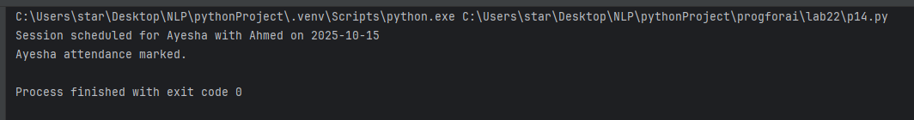

Question # 5: Extend the bank account system to include `SavingsAccount` and `CheckingAccount` classes with different interest rates and withdrawal rules. Implement fund transfer between accounts.
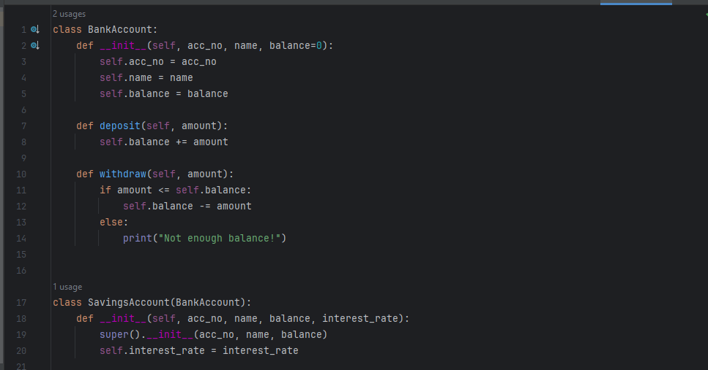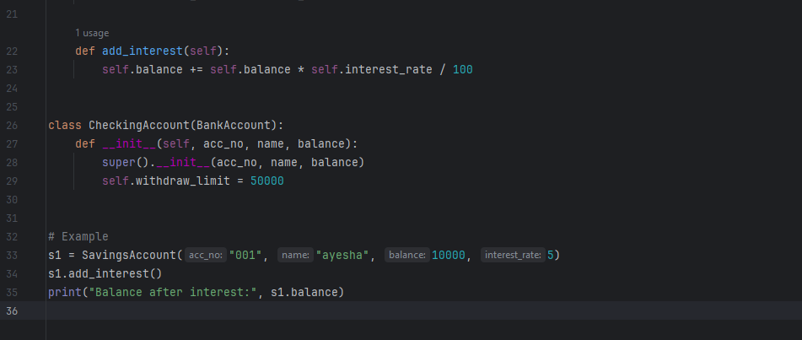
Output
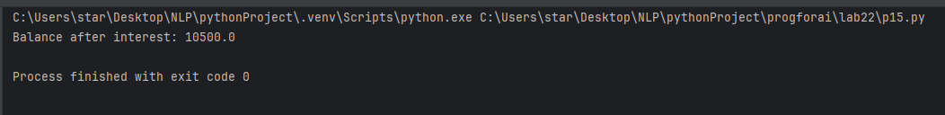

LAB NO 8

OP IN PYTHON P3

Question # 1: Create a `Pizza` class with size, crust type, and toppings. Design an ordering system that calculates prices based on selections and allows custom pizza creation with various topping combinations.
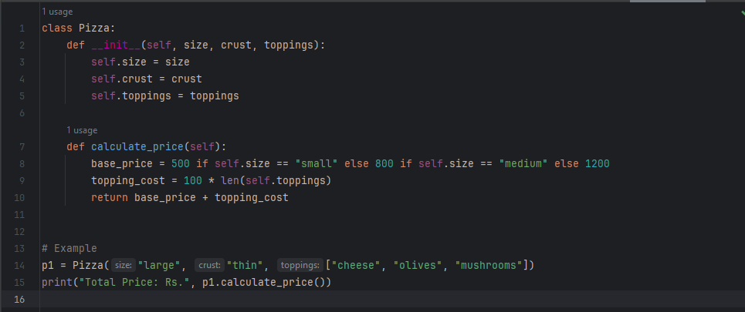
Output :
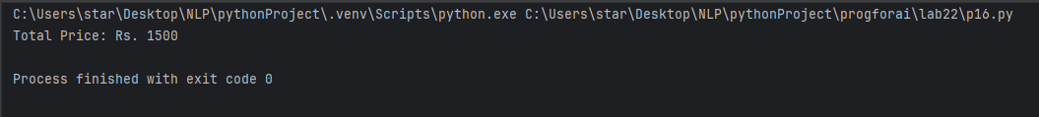

Question # 2: Design classes for `Car` (model, year, color, price) and `CarManufacturer` that can produce different car models with various features. Include quality control checks and production tracking.
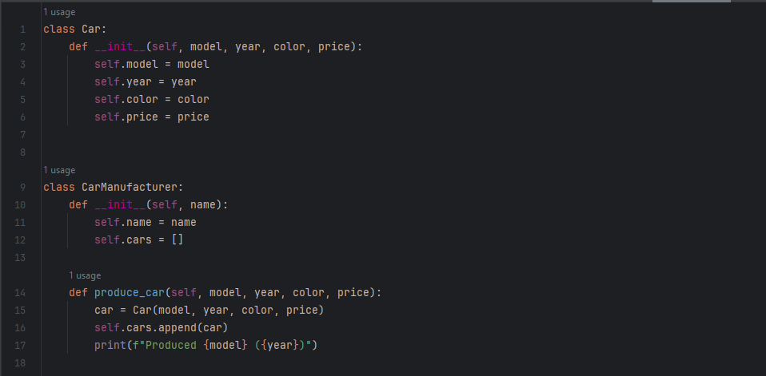
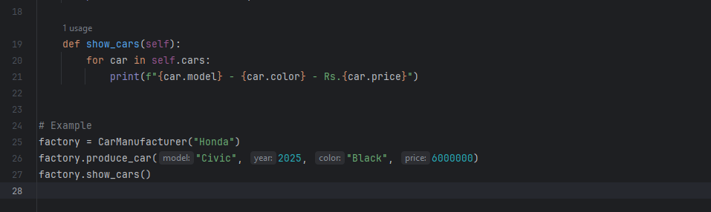
Output
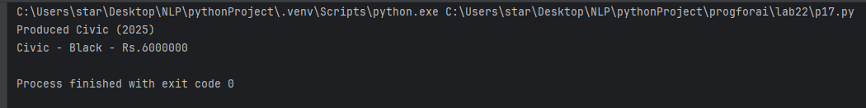

Question # 3: Create `Teacher` and `Student` classes, and a `Classroom` class that manages assignments, grades, and attendance. Implement functionality to track student performance and generate class reports

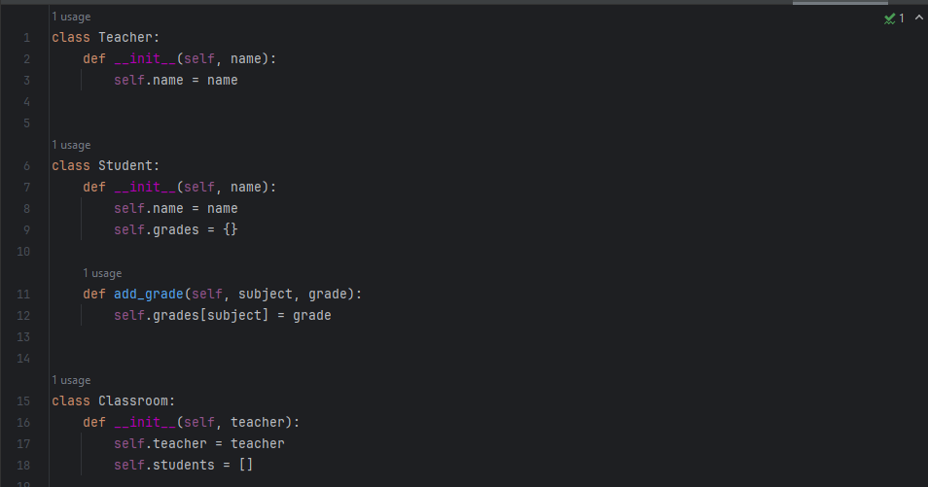
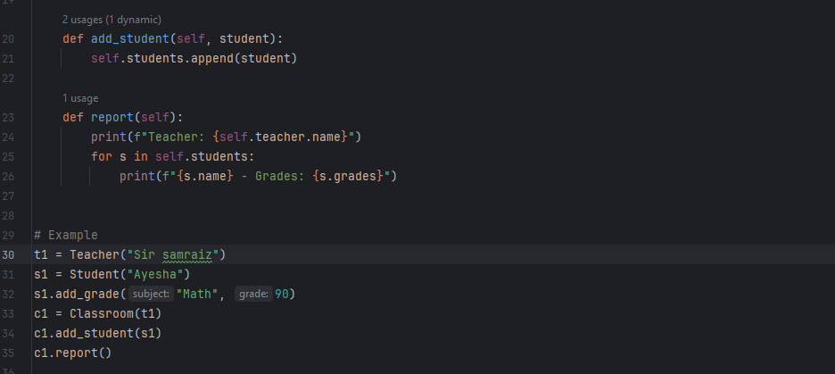
Output
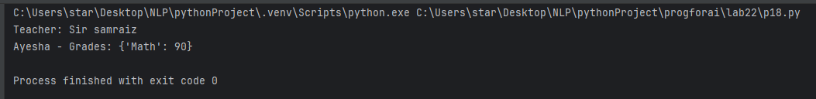

Question # 4: Design `Flight` classes (flight number, destination, departure time, capacity) and a `Passenger` class. Create a booking system that reserves seats and manages passenger manifests

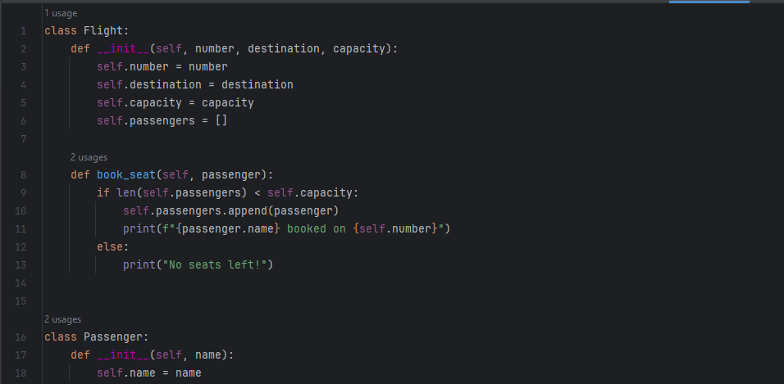
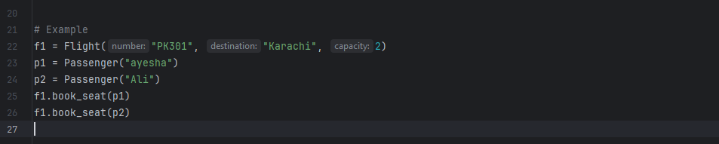
Output
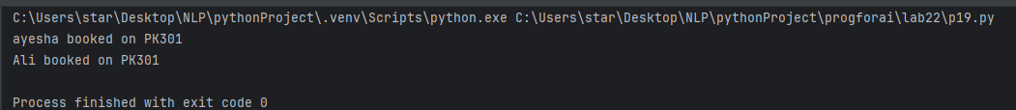

Question # 5: Create classes for `SmartDevice` (base class) and specific devices like `SmartLight`, `Thermostat`, and `SecurityCamera`. Implement a `SmartHome` class that can control all devices and create automation routines

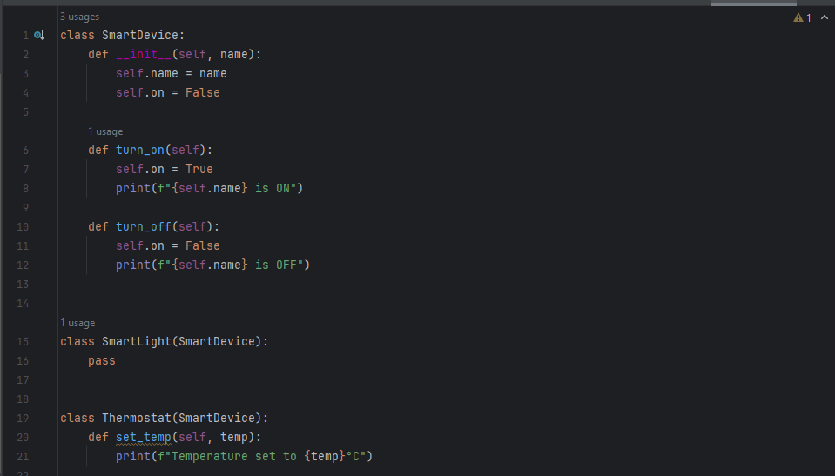
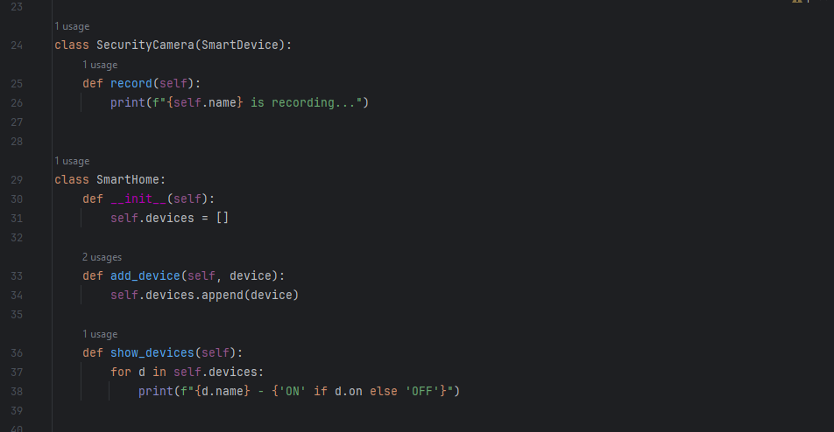
Output :
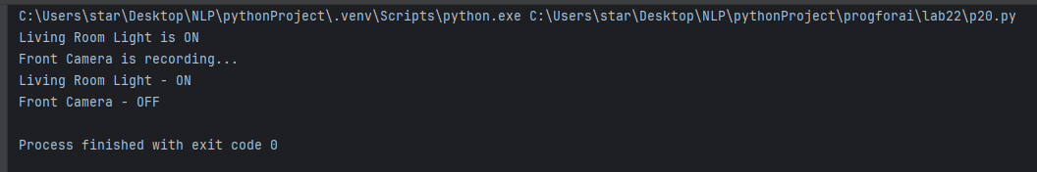
LAB NO 9

NUMPY IN PYTHON

What is NumPy?
NumPy (Numerical Python) is a powerful Python library used for:
- Numerical computations
- Scientific computing
- Data analysis
- Machine learning & AI
✔ It provides fast, efficient arrays and mathematical functions.

Why Use NumPy?
- Faster than Python lists
- Less memory usage
- Supports multi-dimensional arrays
- Built-in mathematical operations

Installing Numpy
pip install numpy

Importing NumPy
import numpy as np

Numpy Array
A Numpy array is a collection of elements of the same data type.
import numpy as np
a = np.array([1, 2, 3, 4])print(a)

Types of Arrays

1D Array
a = np.array([10, 20, 30])

2D Array
b = np.array([[1, 2], [3, 4]])

3D Array
c = np.array([[[1, 2], [3, 4]]])

Array Attributes
print(a.ndim) # dimensionsprint(a.shape) # sizeprint(a.size) # total elementsprint(a.dtype) # data type

Creating Special Arrays
np.zeros((2, 3)) # all zeros
np.ones((3, 2)) # all ones
np.eye(3) # identity matrix
np.arange(1, 10, 2) # range
np.linspace(1, 10, 5)# evenly spaced

Array Indexing & Slicing
a = np.array([10, 20, 30, 40])print(a[1]) # 20print(a[1:3]) # [20 30]
2D slicing:
b[0, 1]

Mathematical Operations
a = np.array([1, 2, 3])
b = np.array([4, 5, 6])
print(a + b)print(a * b)print(np.sqrt(a))

Statistical Functions
np.mean(a)
np.median(a)
np.sum(a)
np.max(a)
np.min(a)
np.std(a)

Reshaping Arrays
a = np.array([1,2,3,4,5,6])
a.reshape(2, 3)

Copy vs View
b = a.copy() # deep copy
c = a.view() # shallow copy

Random Numbers
np.random.rand(3)
np.random.randint(1, 10, 5)

Boolean Indexing
a[a > 2]

Stacking Arrays
np.vstack((a, b))
np.hstack((a, b))

Broadcasting
Allows operations on arrays of different shapes.
a = np.array([1,2,3])print(a + 5)

Question 1: A weather station records temperatures (°C) for 7 days:
[21.1, 23.4, 19.8, 25.0, 26.5, 24.1, 22.0]
Task:
Convert the list into a NumPy array
Find:
Average temperature
Maximum and minimum temperature
Temperature difference (range)

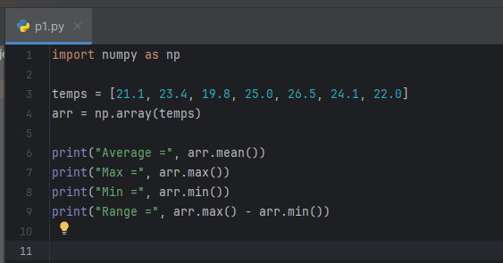
Output
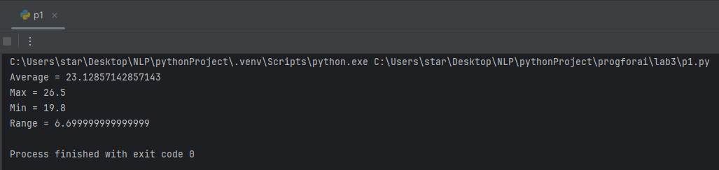

Question 2: A fruit store records daily sales of apples for 4 weeks:
Week 1: [12, 15, 14, 10, 9, 8, 7]
Week 2: [11, 12, 13, 9, 5, 8, 6]
Week 3: [7, 9, 12, 10, 11, 13, 12]
Week 4: [10, 11, 12, 7, 8, 9, 11]
Task:
Create a 4×7 NumPy array
Find weekly totals
Find the highest sale day (index only)
Find the week with the most sales

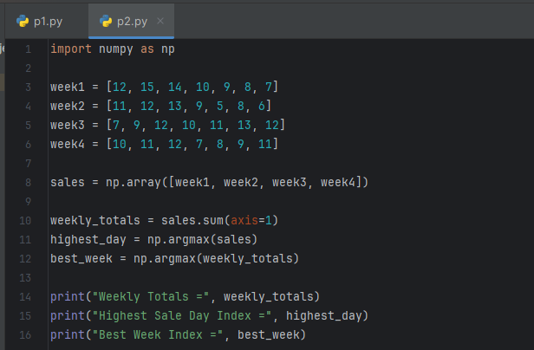
Output :
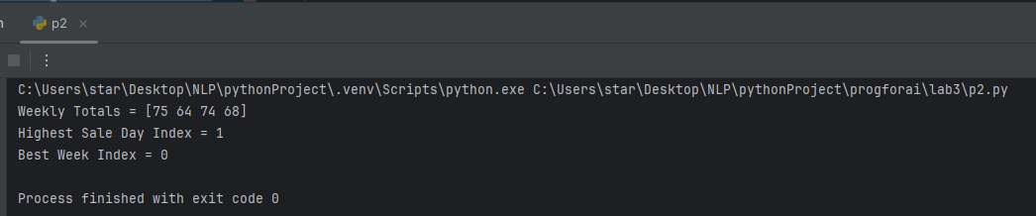

Question 3: Students received marks in a test:
[56, 78, 45, 90, 88, 76, 59, 62]
Task:
Convert to NumPy array
Add 5 bonus marks to every student using broadcasting
Count how many students now scored > 60
Find the median and standard deviation

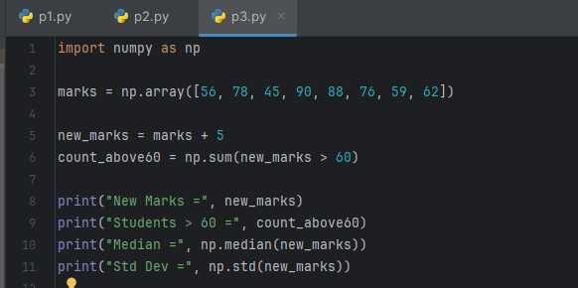
Output :
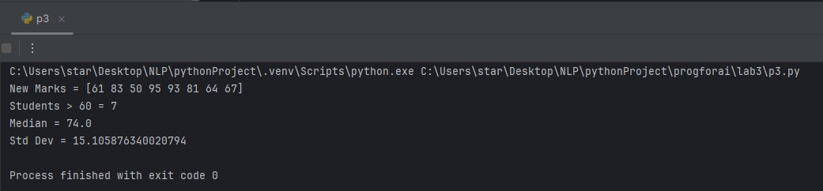
Question 4: A smartwatch stores daily step-counts for a user for 30 days.
Task:
Generate a random NumPy array of shape (30,) with values between 2000–15000
Reshape into a 5×6 matrix
Find:
Weekly average steps
Day with maximum steps
Number of days user crossed 10,000 steps
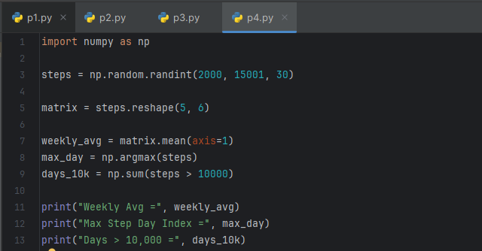
Output :
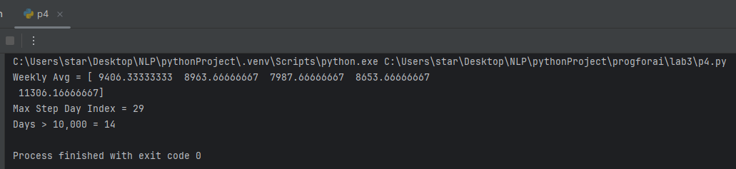

Question 5: Heart rate readings (in BPM) for 10 patients recorded 4 times per day:
Use array shape = (10, 4)
Task:
Create an integer array using np.random.randint(60,150,(10,4))
For each patient:
Compute daily average
Identify abnormal readings > 120
For all patients:
Compute overall maximum and minimum
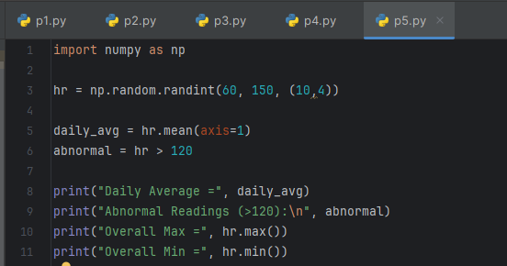
Output :
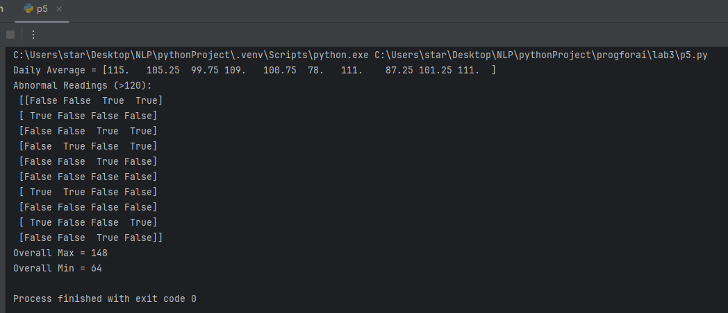

LAB NO 10

NUMPY AS NP IN PYTHON

Question 1: Two branches of a store record monthly sales (in thousands):
Branch A: [122, 135, 150, 160, 155, 140]
Branch B: [110, 130, 148, 165, 158, 145]
Task:
Compute difference between branches
Calculate:
Average monthly sales of each branch
Which branch performed better overall?
Compute correlation between A and B
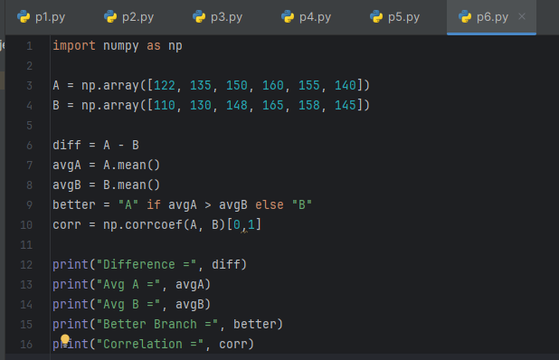
Output :
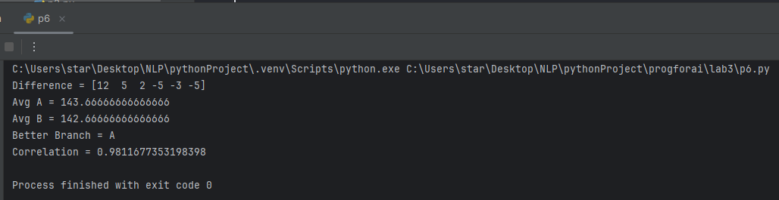

Question 2: Given a 4×4 grayscale image:
[[100, 120, 130, 90 ],
[80 , 110, 140, 100],
[70 , 90 , 120, 130],
[110, 140, 150, 160]]
Task:
Convert to NumPy array
Normalize pixel values (0–1)
Apply a transformation: new_pixel = pixel * 1.2
Clip all values > 255
Compute average brightness before & after transformation
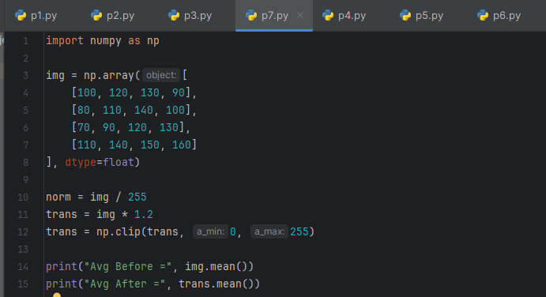
Output :
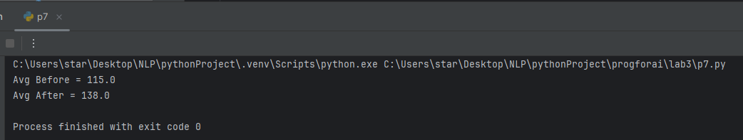
Question 3: Dataset contains 100 samples with 4 features each.
Task:
Generate a 100×4 matrix with values 1–100
Standardize the dataset using:
x_scaled = (x - mean) / std
Perform:
Column-wise mean (should be ≈ 0)
Column-wise variance (should be ≈ 1)
Verify results using NumPy functions
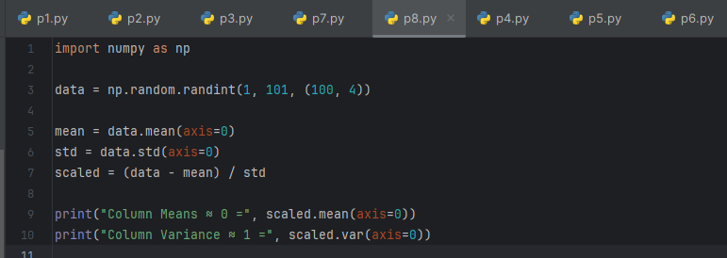
Output :
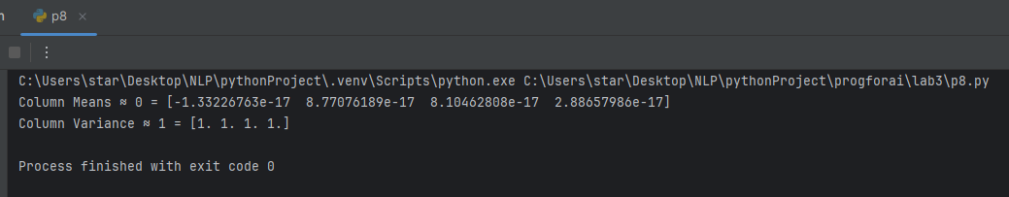

Question 4: Simulate traffic density (cars per minute) recorded by 6 sensors over 24 hours.
Task:
Generate array shape (24, 6)
Find hourly average
Identify the busiest sensor (highest total density)
Apply a threshold:
Replace all values above 50 with 50 (traffic cap)
Compute energy usage:
energy = Σ(sensor_density × 0.5)
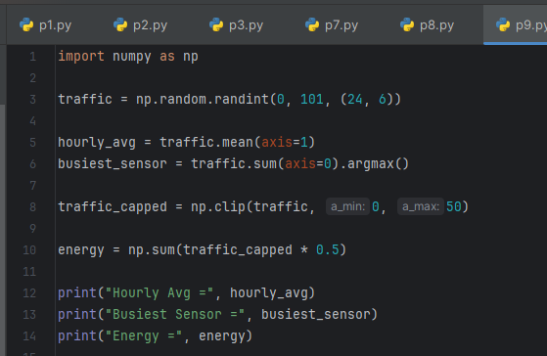
Output :
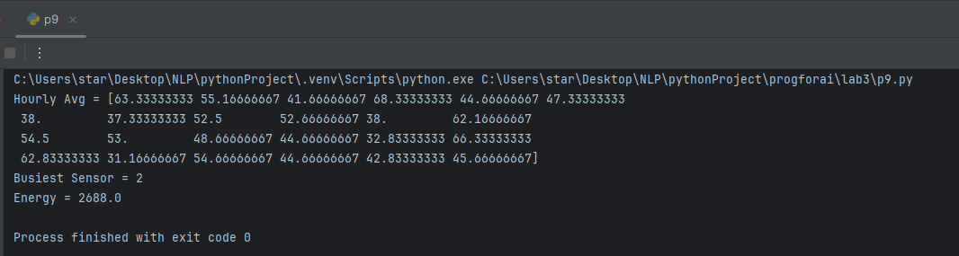

Question 5: You are simulating forces in a mechanical system.
Force vectors applied to 5 components:
F = [[5,2,1],
[3,1,4],
[6,3,2],
[4,2,5],
[7,1,3]]
Transformation matrix:
T = [[2,1,0],
[1,3,1],
[0,2,2]]
Task:
Compute transformed forces: F_new = F × T
Compute magnitude of each force vector
Identify the component experiencing highest transformed force
Perform eigenvalue decomposition of T
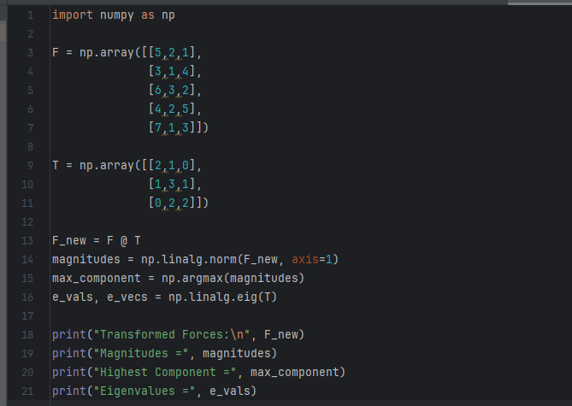
Output :
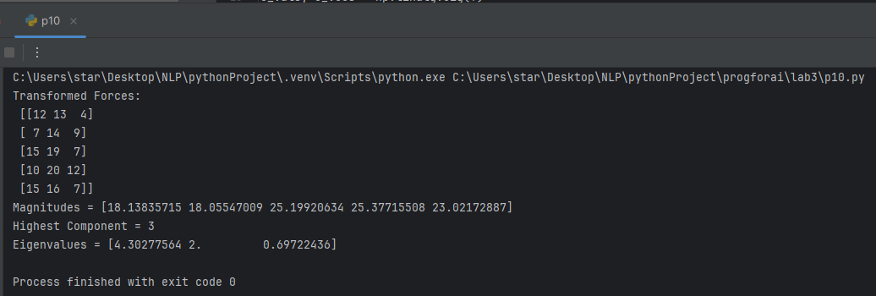

LAB NO 11

SEABORN IN PYTHON

SEABORN

What is Seaborn?
Seaborn is a Python data visualization library built on top of Matplotlib.
It is mainly used to create statistical and attractive graphs easily.
✔ Works best with Pandas DataFrames
✔ Less code, better visuals

Installing Seaborn
pip install seaborn

Importing Seaborn
import seaborn as snsimport matplotlib.pyplot as plt

Why Use Seaborn?
- Beautiful default themes
- Easy statistical plotting
- Built-in datasets
- Better visualization for analysis

Common Seaborn Plots

Line Plot
sns.lineplot(x=[1,2,3], y=[4,5,6])
plt.show()

Bar Plot
sns.barplot(x=["A","B"], y=[10,20])

Histogram
sns.histplot([1,2,2,3,3,3,4])

Box Plot
sns.boxplot(data=[1,2,3,4,10])

Scatter Plot
sns.scatterplot(x=[1,2,3], y=[4,5,6])

Heatmap
import numpy as np
data = np.random.rand(5,5)
sns.heatmap(data)

Built-in Dataset Example
data = sns.load_dataset("tips")
sns.scatterplot(x="total_bill", y="tip", data=data)

Uses of Seaborn
✔ Data exploration
✔ Statistical analysis
✔ Data visualization
✔ Pattern finding

Q1. Patient Stay Analysis (Healthcare)
You are given a dataset containing age, disease_type, and hospital_stay_days.
Write a Python program using Seaborn to:
Plot the distribution of hospital stay days
Compare hospital stay across different disease types
Identify which disease has the highest median stay

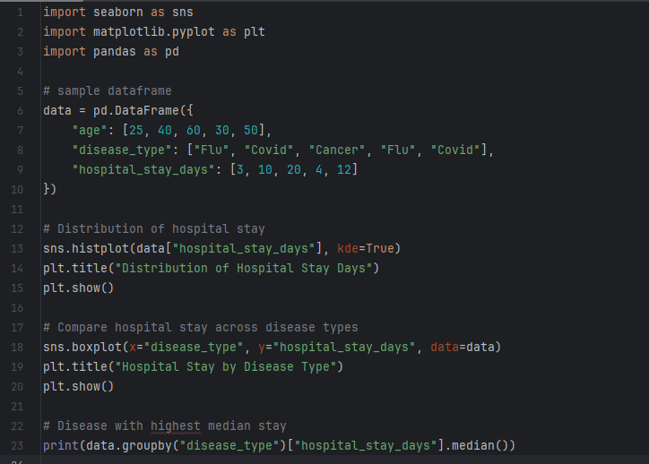


Output:
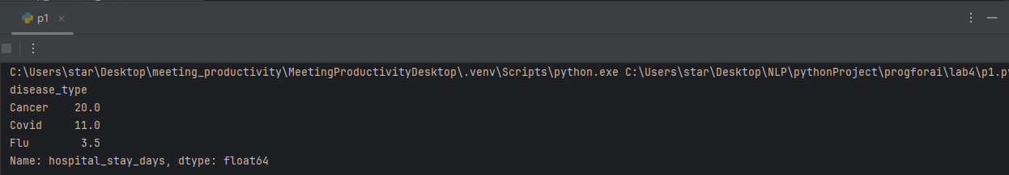

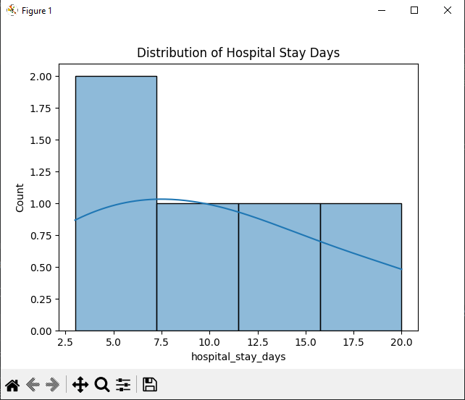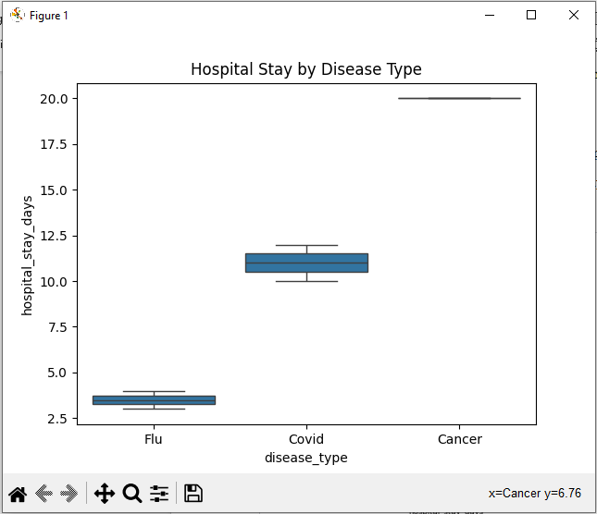

Q2. Sales Distribution Comparison (Business)
A retail dataset contains region and monthly_sales.
Write code to:
Visualize sales distribution per region using Seaborn
Detect regions with high sales variability
Label the axes and add a title
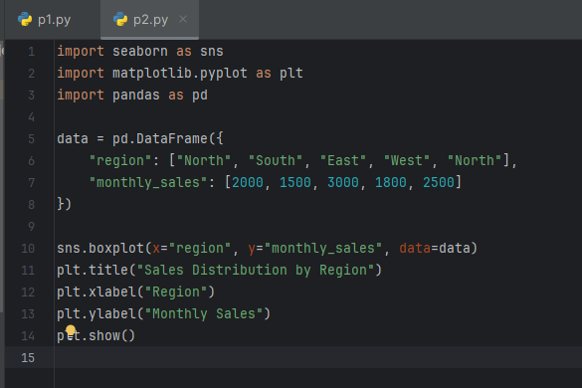
Output:
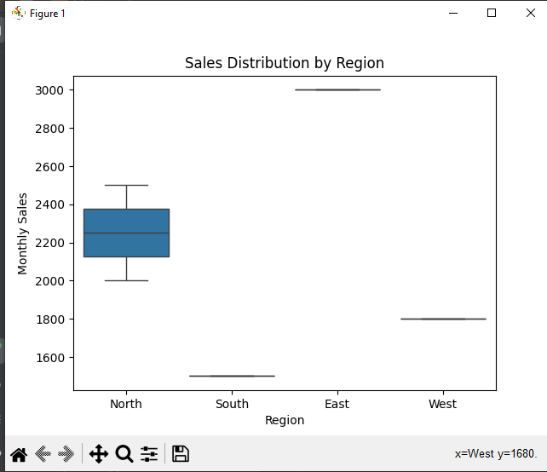

Q3. Student Performance Correlation (Education)
A dataset contains study_hours, attendance, and final_score .
Using Seaborn:
Create a pair plot
Plot a correlation heatmap
Interpret which feature most affects the final score
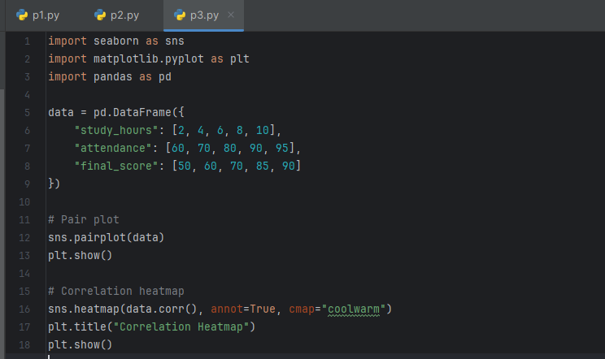
Output:
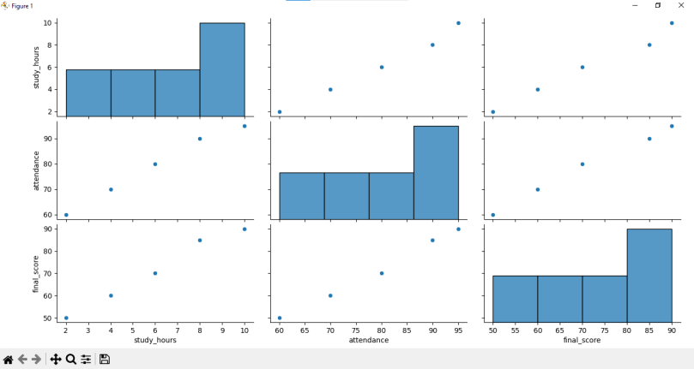

Q4. Customer Segmentation Visualization
Customer data includes age, annual_income, and spending_score.
Write a program to:
Visualize relationships using Seaborn scatter plots
Color-code points based on spending score
Identify potential customer segments visually
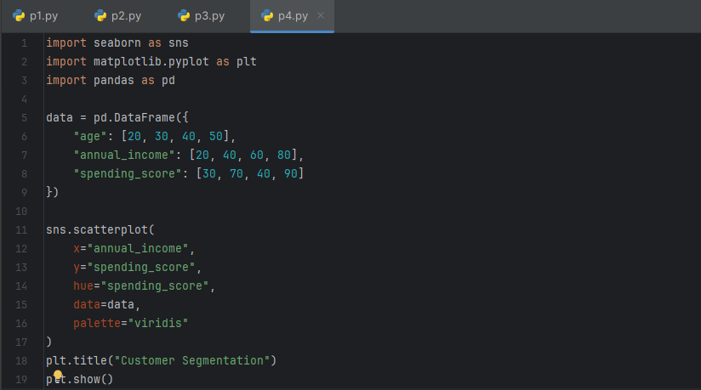
Output:
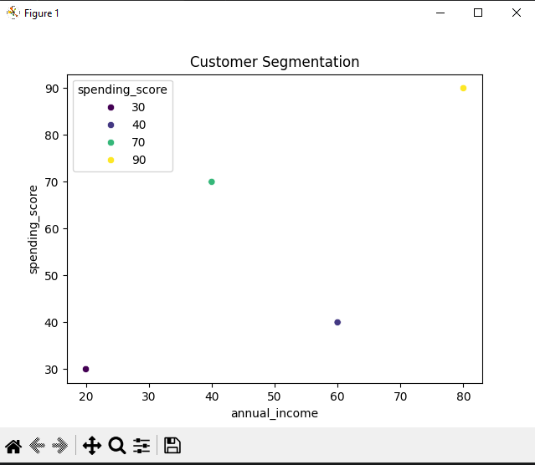

Q5. Model Result Visualization
You trained a classifier and obtained y_true and y_pred.
Write code using Seaborn to:
Plot a confusion matrix heatmap
Add annotations and color bar
Clearly label predicted vs actual classes
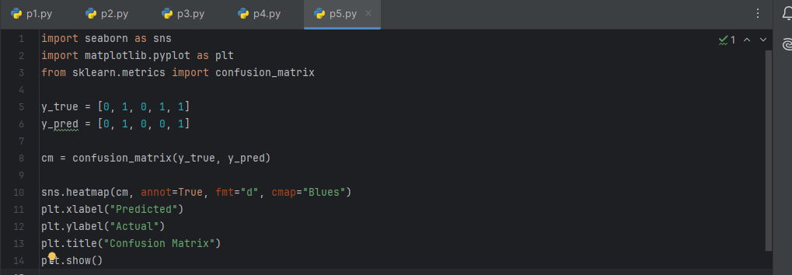
Output:
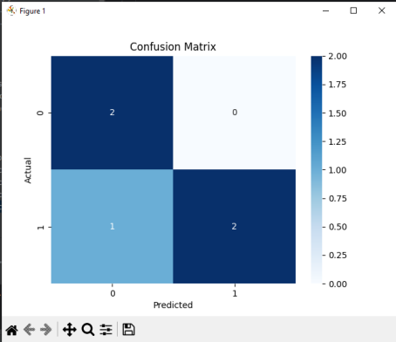

LAB NO 12

SCIKIT-LEARN

SCIKIT-LEARN (SKLEARN)

What is Scikit-Learn?
Scikit-Learn is a machine learning library in Python used for:
- Classification
- Regression
- Clustering
- Model evaluation
✔ Built on NumPy & SciPy
✔ Easy to use ML algorithms

Installing Scikit-Learn
pip install scikit-learn

Importing Scikit-Learn
from sklearn.model_selection import train_test_split

Machine Learning Workflow
- Load data
- Split data
- Choose model
- Train model
- Test model
- Evaluate performance

Common Algorithms in Scikit-Learn

✔ Classification
- Logistic Regression
- Naive Bayes
- KNN
- SVM
- Decision Tree

✔ Regression
- Linear Regression
- Ridge
- Lasso

✔ Clustering
- K-Means
- Hierarchical Clustering

Data Preprocessing
from sklearn.preprocessing import StandardScaler
scaler = StandardScaler()
X_scaled = scaler.fit_transform(X)

Model Evaluation
from sklearn.metrics import classification_reportprint(classification_report(y_test, y_pred))

Uses of Scikit-Learn
✔ Machine Learning
✔ AI projects
✔ Data prediction
✔ Pattern recognition

Seaborn vs Scikit-Learn

Feature | Seaborn | Scikit-Learn
Purpose | Visualization | Machine Learning
Type | Plotting Library | ML Library
Output | Graphs | Predictions
Use | Data analysis | Model building

Q1. Telecom Customer Churn Prediction
Given customer data with features such as tenure, monthly_charges, and contract_type, and target churn.
Write a Scikit-learn program to:
Encode categorical variables
Train a Logistic Regression model
Evaluate using accuracy and confusion matrix
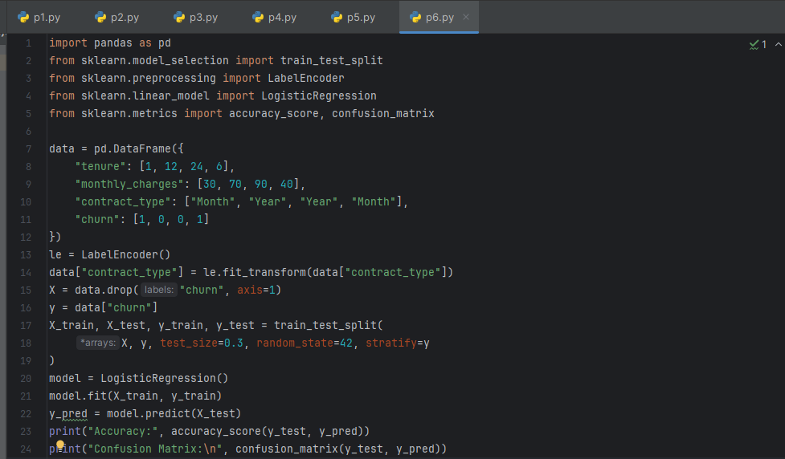
Output:
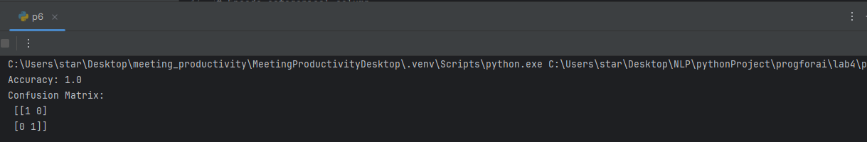

Q2. House Price Prediction
A dataset contains area, bedrooms, location_score, and price.
Implement a regression model to:
Split data into train/test sets
Train Linear Regression
Predict prices and calculate Mean Squared Error
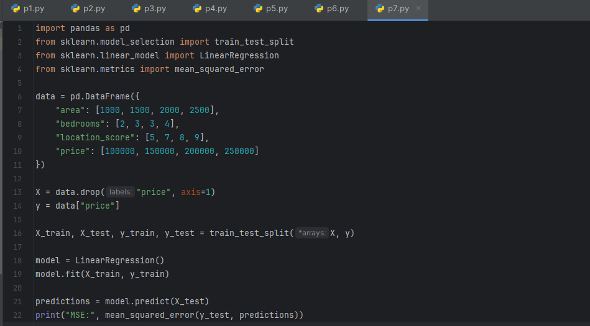
Output:
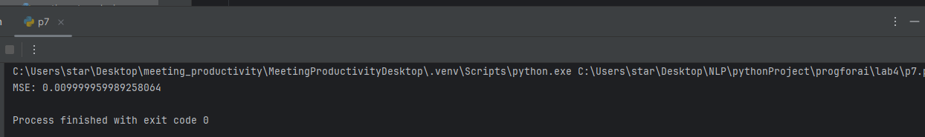

Q3. Disease Classification System
Patient data includes glucose, BMI, age, and outcome.
Write code to:
Normalize the data
Train a Decision Tree classifier
Evaluate precision, recall, and F1-score
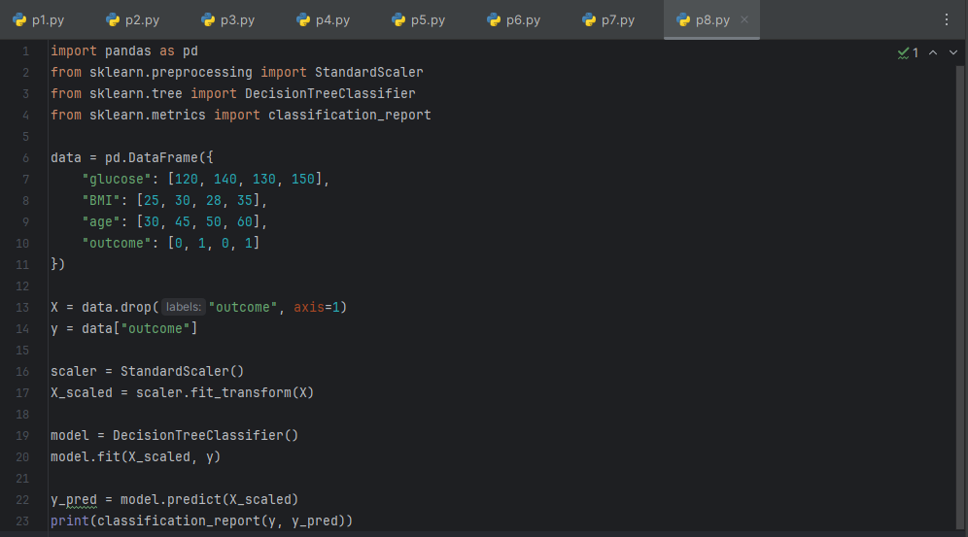
Output:
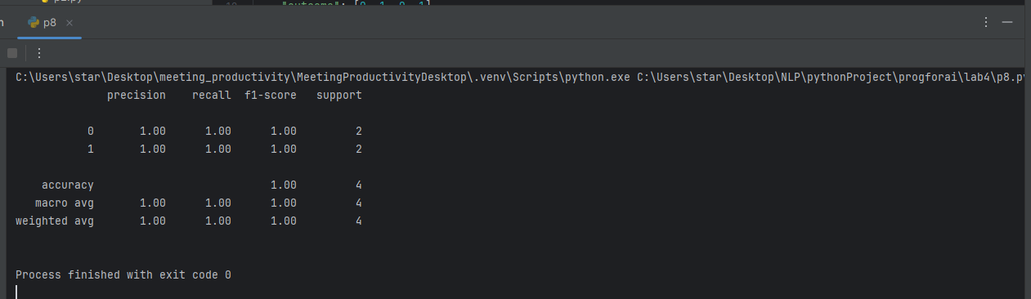

Q4. Email Spam Detection
You are given email text and spam labels.
Using Scikit-learn:
Convert text to numerical features (TF-IDF)
Train a Naive Bayes classifier
Test the model on new email text
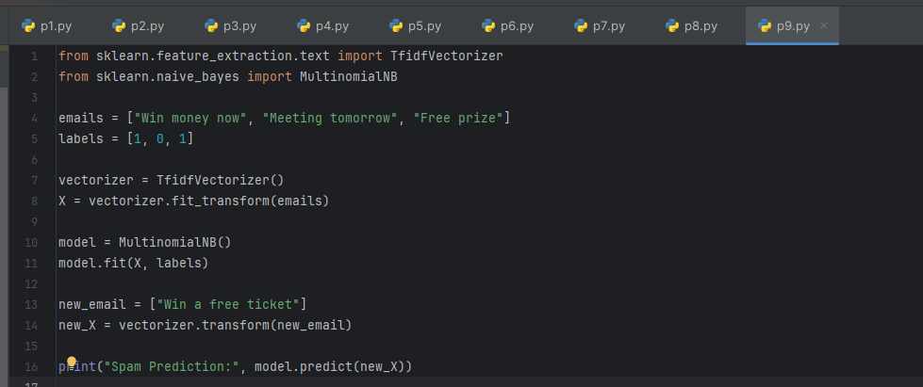
Output:
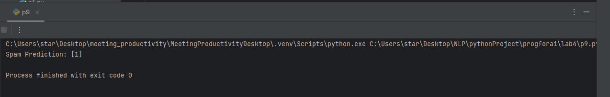
Q5. Student Risk Prediction
Student records include attendance, mid_marks, and final_marks.
Write a program to:
Build a Random Forest classifier
Predict whether a student is “At Risk”
Display feature importance

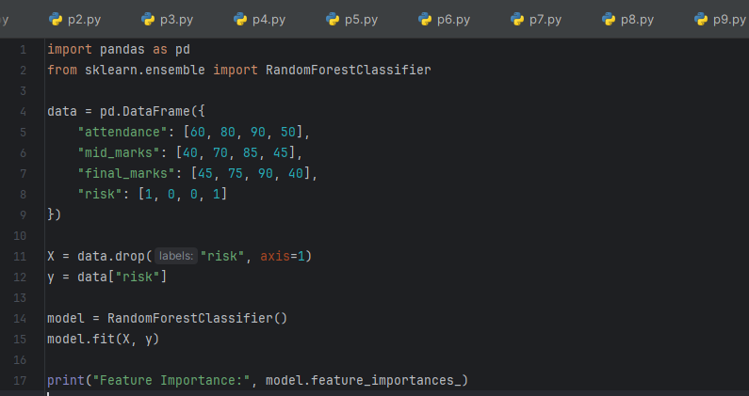


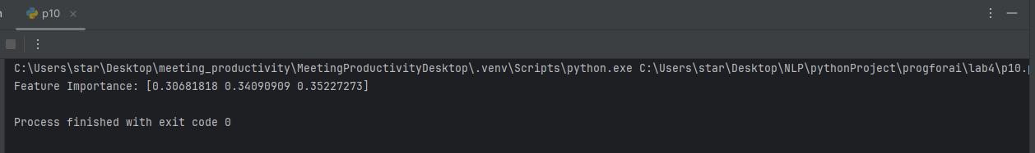

LAB NO 13

TENSORFLOW IN PYTHON

What is TensorFlow?
TensorFlow is an open-source library developed by Google for machine learning (ML) and deep learning (DL). It is widely used to build and train neural networks for tasks like image recognition, natural language processing, and predictive modeling.
Key Features of TensorFlow:
- Multi-platform: Runs on CPU, GPU, mobile devices, and even browsers.
- Flexible: Supports high-level APIs like Keras for easy model building.
- Scalable: Can handle large datasets and distributed training.
- Visualization: Comes with TensorBoard for monitoring and visualizing model performance.

Why is it called TensorFlow?
- Tensor → a fancy name for multi-dimensional data (like arrays, matrices).
- Flow → means data flows through different layers of a neural network.
So TensorFlow = data (tensors) flowing through operations.

Where is TensorFlow used?
TensorFlow is used in:
- Image recognition
- Face detection
- Voice assistants
- Text classification
- Chatbots
- Medical analysis
- Recommendation systems (like Netflix)
- Self-driving cars
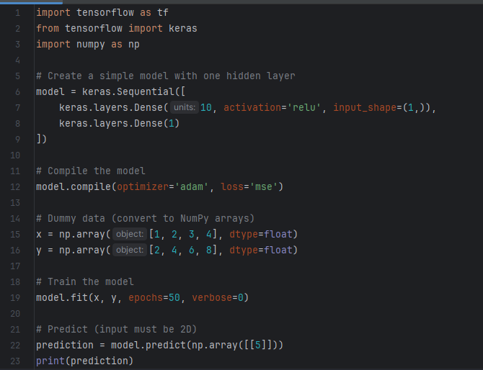
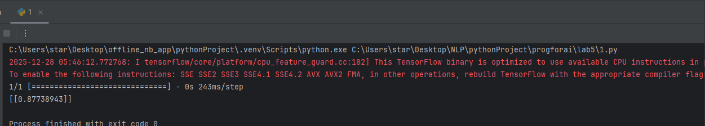

2. How TensorFlow Works
TensorFlow works with tensors, which are just multi-dimensional arrays. It builds a computation graph, where each node represents a mathematical operation, and edges represent data (tensors) flowing between operations.
Key Components:
- Tensors: Basic data structure (like arrays or matrices).
Example: Scalars (0D), Vectors (1D), Matrices (2D), etc.
- Operations (Ops): Mathematical operations applied to tensors (like addition, multiplication).
- Computational Graph: A graph representing the flow of data through operations.
- Sessions (TF1.x) / Eager Execution (TF2.x):
  - TensorFlow 1.x used sessions to run graphs.
  - TensorFlow 2.x executes operations immediately (like regular Python), making it easier to debug
Implementation
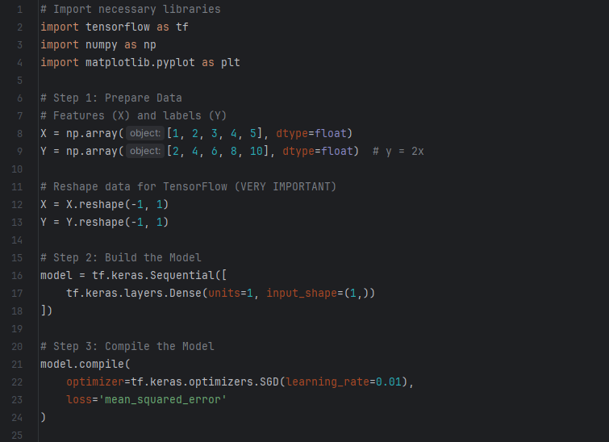
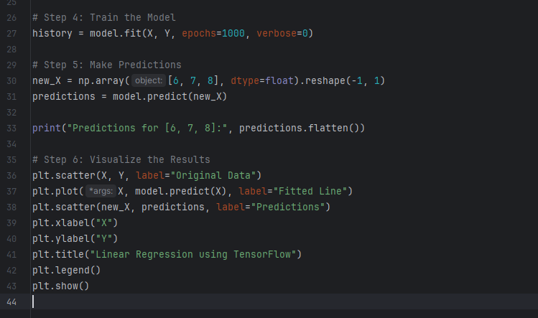
Output
